THE EYE
VOLUME 1

Executive Vision Book
  - The Operating System for Strategic Intelligence
OBSERVE / UNDERSTAND / PREDICT / SIMULATE / DECIDE / LEARN
CONTROLLED EXECUTIVE VISION BASELINE V1.0
Inherited from Volume 0 — Product Constitution v1.0
1 August 2026

Document Control
Volume 1 translates the binding Product Constitution into the executive narrative, institutional value proposition, market category, and long-horizon ambition of The Eye.
CONTROL | VALUE
Product | The Eye
Tagline | The Operating System for Strategic Intelligence
Controlled document | Volume 1 — Executive Vision Book
Edition | 1.0
Issue date | 1 August 2026
Status | Frozen founding executive vision baseline
Binding source | Volume 0 — Product Constitution v1.0
Primary audience | Founders, boards, executives, institutional leaders, partners, senior architects, and strategic operators
Document role | Executive narrative, market relevance, institutional value, and strategic ambition
Next controlled volume | Volume 2 — Technical Presentation

Constitutional inheritance
This book inherits the canonical product name, mission, operating verbs, product principles, ten-layer architecture, human-authority doctrine, source universe, Digital Twin system, Knowledge Graph centrality, prediction horizons, deployment modes, trust obligations, agent governance, and C-001 through C-052 invariants established by Volume 0. It may elaborate the executive meaning of those commitments; it may not narrow or redefine them.

Normative relationship
Volume 1 is authoritative for the executive vision it establishes. Where interpretation conflicts with Volume 0, the Product Constitution prevails until a formal constitutional amendment is ratified. Chapter-end inheritance references and Appendix D preserve traceability to the governing invariant IDs. The architecture remains frozen at the constitutional level; this book defines its executive meaning and target institutional state.

Founding Perspective
The Eye begins from a simple observation: institutions do not fail only because they lack data, intelligence, technology, or talented people. They fail because those capabilities do not operate as one persistent strategic system.
Material evidence is distributed across agencies, business units, research teams, operational systems, advisers, markets, and individual memory. Relationships are reconstructed for each analysis. Assumptions disappear between planning cycles. Forecasts are detached from the decisions they were intended to improve. Scenarios are documented but not monitored. Simulations cannot be reproduced. Recommendations lose their provenance when they enter an executive briefing. Outcomes rarely return to the same system that produced the original view.
The result is an institutional paradox. Organizations possess more information and more analytical power than any generation before them, yet senior leaders still make consequential choices from fragmented pictures of reality. The missing capability is not another interface. It is an operating system that connects observation, understanding, prediction, simulation, decision, and learning around a common model of the world and the organization.
The Eye is built to become that system. It is designed for governments and companies, for high-consequence missions and ordinary strategic operations, for global federated enterprises and focused small businesses. It supports SaaS, Private Cloud, and On-Premise operation because strategic intelligence must function under different sovereignty and control boundaries without becoming a different product.
Its ambition is substantial, but its doctrine is disciplined. The platform will never claim omniscience. It must show what it knows, what it inferred, what remains uncertain, which assumptions carry the conclusion, which evidence would change the view, and who retains authority. Artificial intelligence increases reach; it does not receive final decision rights. Human judgment remains at the center.
FOUNDING PROPOSITION
The Eye turns fragmented evidence into connected understanding, connected understanding into testable futures, testable futures into explainable choices, and choices into organizational learning—without transferring final authority away from people.

Contents
Page references resolve to this controlled edition. Word heading styles are preserved for native navigation.
FRONT
E Executive Thesis 8
PART I — THE STRATEGIC INTELLIGENCE IMPERATIVE
1 The Strategic Environment Has Changed 10
2 Why Institutions Lose Foresight 11
3 The Cost of Fragmented Intelligence 12
4 A New Operating Category 13
5 The Founding Mission and Doctrine 14
6 Human Authority Is a System Property 15
PART II — THE EYE AS A LIVING STRATEGIC SYSTEM
7 One Closed Strategic Loop 17
8 World Observation as a Persistent Field of View 18
9 From Evidence to Understanding 19
10 Enterprise Memory and Strategic Memory 20
11 The Knowledge Graph as the Shared Model of Reality 21
12 Digital Twins as Living Strategic Models 22

CONTENTS CONTINUED
PART II — THE EYE AS A LIVING STRATEGIC SYSTEM — CONTINUED
13 Prediction Across Six Horizons 23
14 Scenario Intelligence and the Discipline of Multiple Futures 24
15 Simulation Before Commitment 25
16 Decision Intelligence and Accountable Choice 26
17 The Executive Operating System 27
18 A Governed Society of AI Agents 28
PART III — STRATEGIC OUTCOMES AND EXECUTIVE WORK
19 Proactive Intelligence and Weak Signals 30
20 Early Warning with Context 31
21 Risk and Opportunity Are Symmetric 32
22 Domain Intelligence as One Connected World 33
23 Supply Chain and Operational Resilience 34
24 The Strategic Health Score 35

CONTENTS CONTINUED
PART III — STRATEGIC OUTCOMES AND EXECUTIVE WORK — CONTINUED
25 Decision Replay and Institutional Learning 36
26 The Strategy Graph and Organizational Alignment 37
27 A Strategic Cadence from Daily Signals to Five-Year Choices 38
PART IV — ENTERPRISE VALUE ACROSS SECTORS
28 Governments and Defence 40
29 Financial Institutions and Healthcare 41
30 Manufacturing, Energy, and Critical Infrastructure 42
31 Logistics, Telecom, and Retail Networks 43
32 Fortune 500, Consulting, and SMEs 44
33 One Core, Governed Specialization 45
PART V — TRUSTWORTHY ENTERPRISE OPERATION
34 Trust, Provenance, and Explainability 47
35 Security, Privacy, Sovereignty, and Resilience 48
36 Three Deployment Modes, One Product 49
37 Continuous Learning with Continuous Evaluation 50

CONTENTS CONTINUED
PART V — TRUSTWORTHY ENTERPRISE OPERATION — CONTINUED
38 Governed Marketplaces and a Strategic Ecosystem 51
39 Adoption, Value, and Strategic Maturity 52
PART VI — THE STRATEGIC INTELLIGENCE ENTERPRISE
40 The Strategic Intelligence Enterprise 54
41 Category Leadership and Institutional Defensibility 55
42 The Long Horizon 56
APPENDICES
A Executive Terminology 57
B The Ten Layers at a Glance 59
C Executive Value Map 60
D Constitutional Inheritance Index 61

Executive Thesis
The Eye will become the institutional system through which consequential organizations continuously orient to change, understand relationships, test possible futures, make accountable decisions, and learn across generations of leadership.

The problem
Strategic intelligence is fragmented across sources, systems, functions, suppliers, advisers, models, and people. Organizations can retrieve information and produce analysis, yet they struggle to maintain one connected view of what changed, why it matters, which futures are plausible, what action is available, and what earlier decisions have taught them.

The category
The Eye is a Strategic Intelligence Operating System. It coordinates data, knowledge, memory, models, agents, Digital Twins, forecasts, scenarios, simulations, recommendations, decisions, actions, outcomes, and learning around a common governed representation of the world and the enterprise.

The strategic promise
- Observe the external and internal world continuously with measurable coverage and preserved evidence.
- Understand entities, events, claims, relationships, mechanisms, conflict, and uncertainty before predicting.
- Predict across 30-day, 90-day, 180-day, 1-year, 3-year, and 5-year horizons with calibration and explanation.
- Simulate shocks, policies, investments, and strategies against versioned Digital Twins and coherent scenarios.
- Decide through complete, traceable packages in which a named human authority retains final responsibility.
- Learn from outcomes through Decision Replay, Strategic Memory, evaluation, and governed release processes.
INSTITUTIONAL OUTCOME
The Eye changes strategy from a periodic document into a continuous institutional capability: a persistent, explainable, human-governed operating system that shortens time-to-understanding, preserves options, strengthens accountability, protects strategic memory, and compounds learning without creating a black-box decision-maker.
CONSTITUTIONAL INHERITANCE / C-001 · C-002 · C-004 · C-052

PART I
The Strategic Intelligence Imperative
Why institutions require a new operating system for understanding change and governing consequential decisions.
THE EYE / THE OPERATING SYSTEM FOR STRATEGIC INTELLIGENCE

1 The Strategic Environment Has Changed
Institutions are making longer-range commitments inside an environment that changes faster than their planning, reporting, and governance cycles were designed to absorb.

The compression of decision time
Political decisions, regulatory action, technological discontinuities, capital flows, supply shocks, cyber events, scientific advances, climate conditions, and social narratives now propagate across domains with little respect for organizational boundaries. An event that appears local can alter procurement, financing, security, reputation, operations, and strategy within the same decision cycle. The central executive problem is no longer access to information. It is the ability to establish what changed, understand the relationships that make the change material, and decide before the window for effective action closes.

The widening field of consequence
Senior leaders must reason across systems that were historically governed separately: market position and regulation, technology and national policy, supply resilience and climate, workforce and automation, financial exposure and geopolitical alignment. These systems interact through delayed, indirect, and second-order effects. Conventional reporting is strongest where the environment is stable and the questions are known. Strategic intelligence is required where the questions emerge from the change itself.

From periodic planning to continuous orientation
The annual strategy cycle remains useful for allocating intent, but it cannot be the institution's only mechanism for orientation. Strategy must become a continuously maintained body of objectives, assumptions, indicators, choices, commitments, and learning. The Eye is designed for that operating condition. It gives leadership a persistent system that remains connected to the external world and to the internal reality of the enterprise between planning events.
EXECUTIVE PROPOSITION
The advantage belongs to institutions that can shorten the distance between material change, shared understanding, accountable choice, and organizational learning.
CONSTITUTIONAL INHERITANCE / C-002 · C-032 · C-049

2 Why Institutions Lose Foresight
Strategic blindness is usually not caused by the absence of intelligence. It is caused by the loss of connection between evidence, context, ownership, assumptions, and decisions.

Fragmentation creates false calm
Signals arrive through research teams, market data, legal counsel, policy units, security operations, customer channels, ERP systems, supply-chain partners, sensors, consultants, and executive relationships. Each source may be competent within its mandate. The institution still fails when the pieces cannot be connected in time. Material evidence remains trapped in documents, inboxes, dashboards, data platforms, and individual memory; no shared system establishes how one change alters objectives, risks, capabilities, or decisions elsewhere.

Memory disappears at organizational boundaries
Leadership transitions, reorganizations, project closures, vendor changes, and ordinary staff turnover erase context that was never written into a durable strategic record. A decision may be preserved while the assumptions that made it reasonable vanish. The same investigation is repeated, the same risk is rediscovered, and the same option is debated without access to the earlier evidence or outcome. This is not a knowledge-management inconvenience. It is a failure of institutional continuity.

Uncertainty is compressed into narrative
Executive communication often rewards a single answer even when the evidence supports several plausible interpretations. Conflicting claims are flattened, confidence is stated without calibration, and scenario-dependent recommendations are presented as universal conclusions. The result may look decisive while concealing the information most relevant to judgment: what is known, what is inferred, what is disputed, what would falsify the view, and which assumptions are carrying the recommendation.
- Data without context produces volume, not orientation.
- Analysis without memory produces repetition, not learning.
- Prediction without relationships produces fragile confidence.
- Recommendations without provenance produce authority without accountability.
CONSTITUTIONAL INHERITANCE / C-010 · C-015 · C-016

3 The Cost of Fragmented Intelligence
When intelligence remains fragmented, the enterprise pays in delayed recognition, inconsistent action, duplicated analysis, strategic drift, and avoidable exposure.

Delay is a strategic cost
The most expensive delay is not the time required to produce a report. It is the time between the first observable change and the moment the institution understands its consequence. During that interval, competitors reposition, regulators shape the operating space, suppliers reallocate capacity, narratives harden, and options expire. The Eye treats detection latency, interpretation latency, decision latency, and action latency as distinct conditions that can be measured and improved.

Local optimization becomes enterprise contradiction
A procurement team can reduce unit cost while increasing geopolitical concentration. A business unit can accelerate growth while creating regulatory exposure. A technology program can improve capability while weakening sovereignty or resilience. These contradictions are often discovered only after commitments are made because each decision was evaluated inside a narrow frame. Strategic intelligence provides a shared frame in which local choices can be assessed against enterprise objectives, dependencies, and second-order effects.

The hidden tax on executive attention
Senior leaders spend disproportionate time reconciling numbers, locating evidence, testing whether teams mean the same thing, and rebuilding the history of a decision. This attention tax crowds out judgment. The purpose of The Eye is not to automate executive responsibility. It is to ensure that human attention is spent on material choices rather than on reconstructing the system of record that should already exist.
VALUE PRINCIPLE
The platform creates value when it reduces time-to-understanding, preserves strategic options, improves decision quality, and prevents the institution from paying repeatedly for lost context.
CONSTITUTIONAL INHERITANCE / C-006 · C-025 · C-049

4 A New Operating Category
The Eye is not another analytical interface. It defines a new enterprise category: the Strategic Intelligence Operating System.

Why the operating-system model matters
An operating system supplies shared services, memory, identity, permissions, policies, interfaces, and execution controls so many forms of work can operate coherently. The Eye performs the equivalent function for strategic intelligence. It coordinates observations, claims, entities, relationships, models, agents, Digital Twins, forecasts, scenarios, simulations, recommendations, decisions, actions, outcomes, and lessons around a common representation of the world and the organization.

More than the interfaces it may contain
The platform may present dashboards, maps, timelines, graph exploration, alerts, reports, APIs, decision rooms, and conversational interaction. None of those surfaces defines the product. They are access modes to a deeper system that persists between sessions, preserves truth states and provenance, understands relationships, governs machine authority, and maintains a closed loop from observation to learning. A chatbot answers a question. The Eye maintains the institutional system within which the question, evidence, answer, decision, and outcome remain connected.

A category built around decisions
Business intelligence is commonly organized around metrics. Knowledge management is organized around content. AI assistants are organized around tasks or conversations. The Eye is organized around consequential decisions and the strategic conditions that shape them. Its primary unit is the governed intelligence object and its ultimate unit of value is the accountable decision improved over time.
CATEGORY DEFINITION
A Strategic Intelligence Operating System is a persistent enterprise system that observes change, builds connected understanding, constructs and tests possible futures, supports accountable human decisions, and learns from outcomes.
CONSTITUTIONAL INHERITANCE / C-001 · C-003 · C-035

5 The Founding Mission and Doctrine
The Eye turns a changing world into connected understanding, testable futures, explainable choices, and durable organizational learning.

The mission
The Eye continuously observes the external and internal world, understands relationships between events, builds organizational memory, predicts possible futures, simulates strategic decisions, and provides explainable recommendations for human decision-makers. The mission is intentionally circular rather than linear. Every outcome becomes new evidence; every lesson changes how the institution observes, interprets, and acts.
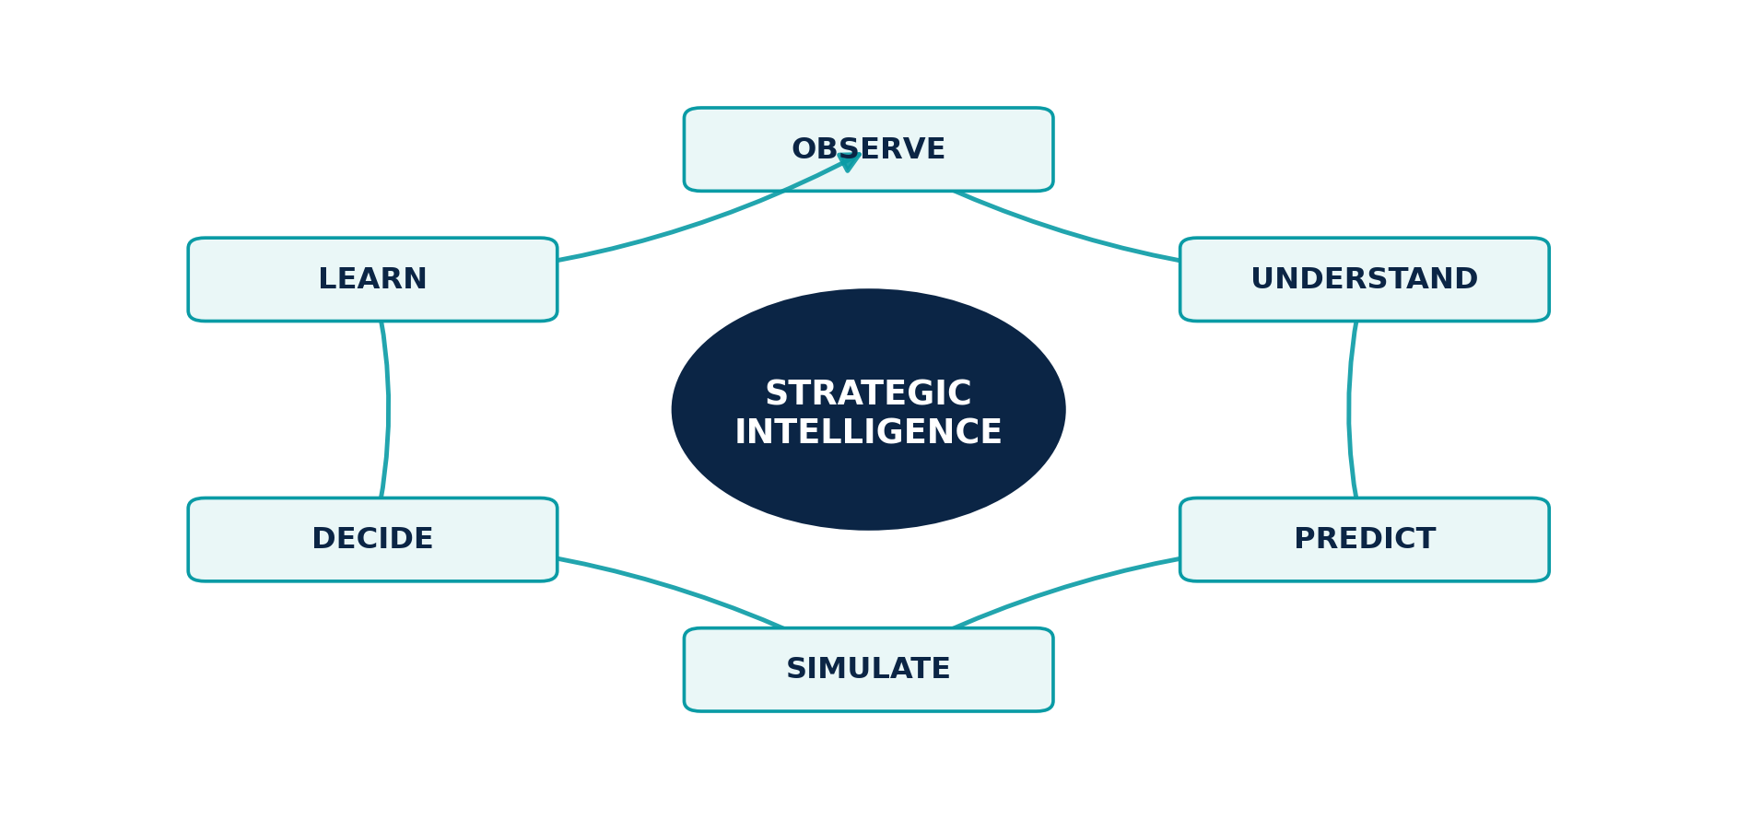
Figure 1. The six-stage strategic intelligence loop.

The six operating verbs
Observe. Acquire and preserve authorized evidence about the external world and the enterprise.
Understand. Resolve evidence into entities, events, claims, relationships, context, mechanisms, and uncertainty.
Predict. Estimate future conditions across the six canonical horizons using calibrated, explainable methods.
Simulate. Test shocks, actions, and strategies against grounded Digital Twins and declared assumptions.
Decide. Present accountable humans with options, consequences, trade-offs, uncertainty, and recommendations.
Learn. Compare expectations with outcomes and improve memory, models, workflows, and policy through governance.
Doctrine. Observe Everything establishes reach; Understand Before Predicting, epistemic discipline; Explain Every Recommendation, accountability; Humans Decide, authority; Learn Continuously, adaptation; Remember Permanently, continuity; Protect by Design and Enterprise First, the operating standard.
CONSTITUTIONAL INHERITANCE / C-002 · C-005 · C-052

6 Human Authority Is a System Property
The Eye expands the reach of machine-supported reasoning while keeping final strategic authority, moral responsibility, and legal accountability with people.

Humans decide
The platform may discover, collect, classify, summarize, reason, forecast, generate options, run simulations, rank alternatives, draft recommendations, and execute narrowly pre-authorized reversible administration. It may not silently assume final decision rights. Every strategic or high-impact decision must identify the accountable human authority, the evidence and recommendations available, the review process, the approval state, and any override or dissent.

Human control must be substantive
A final click is not meaningful human control if material evidence is hidden, uncertainty is compressed, alternatives are suppressed, or the workflow makes challenge impractical. The Eye is designed to make judgment stronger: it exposes provenance, assumptions, confidence, scenarios, sensitivity, competing interpretations, and the consequences of delay. Human authority is therefore enforced through product architecture, workflow, policy, audit, and interface design rather than through a disclaimer.

Machine speed, human accountability
Agents and models can operate at a scale and cadence that no executive team can reproduce manually. Their role is to widen the field of view, preserve consistency, identify change, test hypotheses, and prepare decisions. The institution remains responsible for purpose, proportionality, lawful authority, policy, risk appetite, and action. The platform must make that responsibility visible at the exact point where a recommendation becomes a commitment.
NON-NEGOTIABLE BOUNDARY
The Eye recommends, forecasts, simulates, reasons, and explains. A named human authority makes the final decision.
CONSTITUTIONAL INHERITANCE / C-004 · C-028 · C-050

PART II
The Eye as a Living Strategic System
How observations, knowledge, memory, twins, foresight, simulation, decisions, and agents operate as one governed system.
THE EYE / THE OPERATING SYSTEM FOR STRATEGIC INTELLIGENCE

7 One Closed Strategic Loop
The Eye is coherent because every stage produces governed objects that the next stage can use and the previous stage can audit.

Continuity from evidence to outcome
An observation becomes strategically useful when it can be traced into a claim, connected to entities and events, interpreted in context, incorporated into a forecast or scenario, tested through simulation, weighed inside a recommendation, reviewed by a human decision authority, and compared with the eventual outcome. The Eye preserves this chain as a living system. It does not break intelligence into disconnected products or allow a polished output to lose the evidence and assumptions that produced it.

The loop re-enters itself
Strategic work does not advance through a single pipeline. A simulation can expose a missing observation. A new regulation can invalidate a twin state. A decision review can require another scenario. An outcome can reveal that the ontology, model, threshold, or source strategy was wrong. The platform supports controlled iteration while preserving every prior state, the reason for revision, and the actors who approved it.

The governing object model
The loop is built from explicit objects rather than loose text: evidence, claims, entities, events, relationships, assessments, hypotheses, indicators, objectives, risks, opportunities, capabilities, forecasts, scenarios, simulations, recommendations, decisions, actions, outcomes, and lessons. Each object carries identity, time, provenance, truth state, ownership, policy, confidence, version, and lifecycle status appropriate to its role.
SYSTEM TEST
If a recommendation cannot be traced backward to evidence and forward to the human decision and outcome, the strategic loop is broken.
CONSTITUTIONAL INHERITANCE / C-002 · C-010 · C-025

8 World Observation as a Persistent Field of View
Observation is not scraping. It is the governed acquisition and preservation of evidence, including an honest model of what the institution cannot currently see.

A universal source universe
The Eye is designed to monitor governments, regulations, news, financial markets, research, scientific papers, patents, company filings, supply chains, IoT, ERP, CRM, internal documents, satellites, climate, geopolitical events, social signals, APIs, RSS, and customer-defined sources. Each source class introduces distinct questions of authority, rights, structure, latency, quality, authenticity, and interpretation. The platform treats those questions as part of the intelligence itself.

Observation with chain of custody
Every collected object preserves where it came from, how it was acquired, when the underlying event occurred, when it was published and collected, which connector and parser handled it, what rights govern its use, and whether it has been corrected, withdrawn, transformed, or contradicted. Derived intelligence never replaces the original evidence. The institution can always return to the source record permitted by policy.

Coverage intelligence
A field of view is only trustworthy when its limits are visible. The Eye models source gaps, failed connectors, delayed feeds, licensing exclusions, geographic blind spots, sampling bias, sensor degradation, and collection uncertainty. Downstream analysis can therefore distinguish an absence of evidence from evidence of absence. Coverage itself becomes a strategic indicator.
- Discover and authorize sources before operational use.
- Measure freshness, completeness, health, and representativeness.
- Isolate manipulated or malicious content from tools and policy control.
- Propagate corrections to every downstream intelligence object affected.
CONSTITUTIONAL INHERITANCE / C-012 · C-013 · C-014

9 From Evidence to Understanding
The Intelligence Layer builds structured understanding while preserving the difference between what was observed, what was asserted, what was inferred, and what a human accepted.

A governed transformation system
Collection and cleaning are followed by classification, summarization, named-entity recognition, entity resolution, event extraction, relationship extraction, claim extraction, topic and theme analysis, geospatial and temporal alignment, contradiction detection, weak-signal detection, and analytical assessment. Deterministic methods, statistical models, foundation models, graph algorithms, domain models, and human review may all contribute. The platform records which method produced each result and under which version.

Truth states prevent semantic collapse
Observed evidence, source claims, model inference, analyst assessment, forecast, scenario assumption, simulation output, recommendation, decision, and outcome are different classes of truth. The Eye never treats them as interchangeable. A model-detected relationship is not presented as an observed fact; a scenario is not presented as a forecast; an executive approval is not retroactively described as machine judgment. These distinctions remain visible in storage, APIs, graph edges, user interfaces, and audit.

Disagreement is retained, not averaged away
Strategic intelligence frequently contains competing interpretations. The platform preserves supporting and contradicting evidence, source dependence, alternative hypotheses, confidence, missing information, and review status. Analysts can endorse, challenge, amend, or supersede an assessment without deleting its history. Leadership receives a structured view of disagreement rather than a falsely unified answer.
EXECUTIVE CONSEQUENCE
Understanding is achieved when the institution can explain what changed, which relationships make it material, how confident the assessment is, and what evidence would change the view.
CONSTITUTIONAL INHERITANCE / C-010 · C-011 · C-045

10 Enterprise Memory and Strategic Memory
The Eye remembers not only documents and data, but the context required to understand what the institution knew, believed, assumed, decided, attempted, and learned.

Enterprise Memory
Enterprise Memory is the governed durable memory of sources, documents, communications, telemetry, entities, events, claims, analyses, workflows, decisions, actions, and outcomes. It spans structured and unstructured information while preserving provenance, time, access policy, classification, tenant, version, and correction history. Retrieval is semantic, contextual, and permission-aware rather than merely lexical.

Strategic Memory
Strategic Memory is the decision-centered interpretation layer within Enterprise Memory. It preserves objectives, hypotheses, assumptions, scenarios, forecasts, simulation configurations, recommendations, alternatives, dissent, approvals, commitments, outcomes, post-decision reviews, and lessons. It allows a future leader to reconstruct why a choice was reasonable using the evidence available at the time, without contaminating the record with hindsight.

Permanent memory with lawful forgetting
Remember Permanently means that strategic context does not disappear through application boundaries, staff turnover, or model context windows. It does not override law, contract, consent, classification, security policy, or customer-directed deletion. Retention, archival, legal hold, correction, redaction, and verifiable deletion are governed capabilities. The system preserves institutional continuity while respecting authorized boundaries.
MEMORY PRINCIPLE
Model output does not become institutional truth merely because it was generated. Memory writes carry truth state, provenance, confidence, owner, review status, expiry, and correction history.
CONSTITUTIONAL INHERITANCE / C-015 · C-016 · C-040

11 The Knowledge Graph as the Shared Model of Reality
The Knowledge Graph is the connected semantic heart of The Eye: the place where the world, the enterprise, and strategic intent become one inspectable system of relationships.
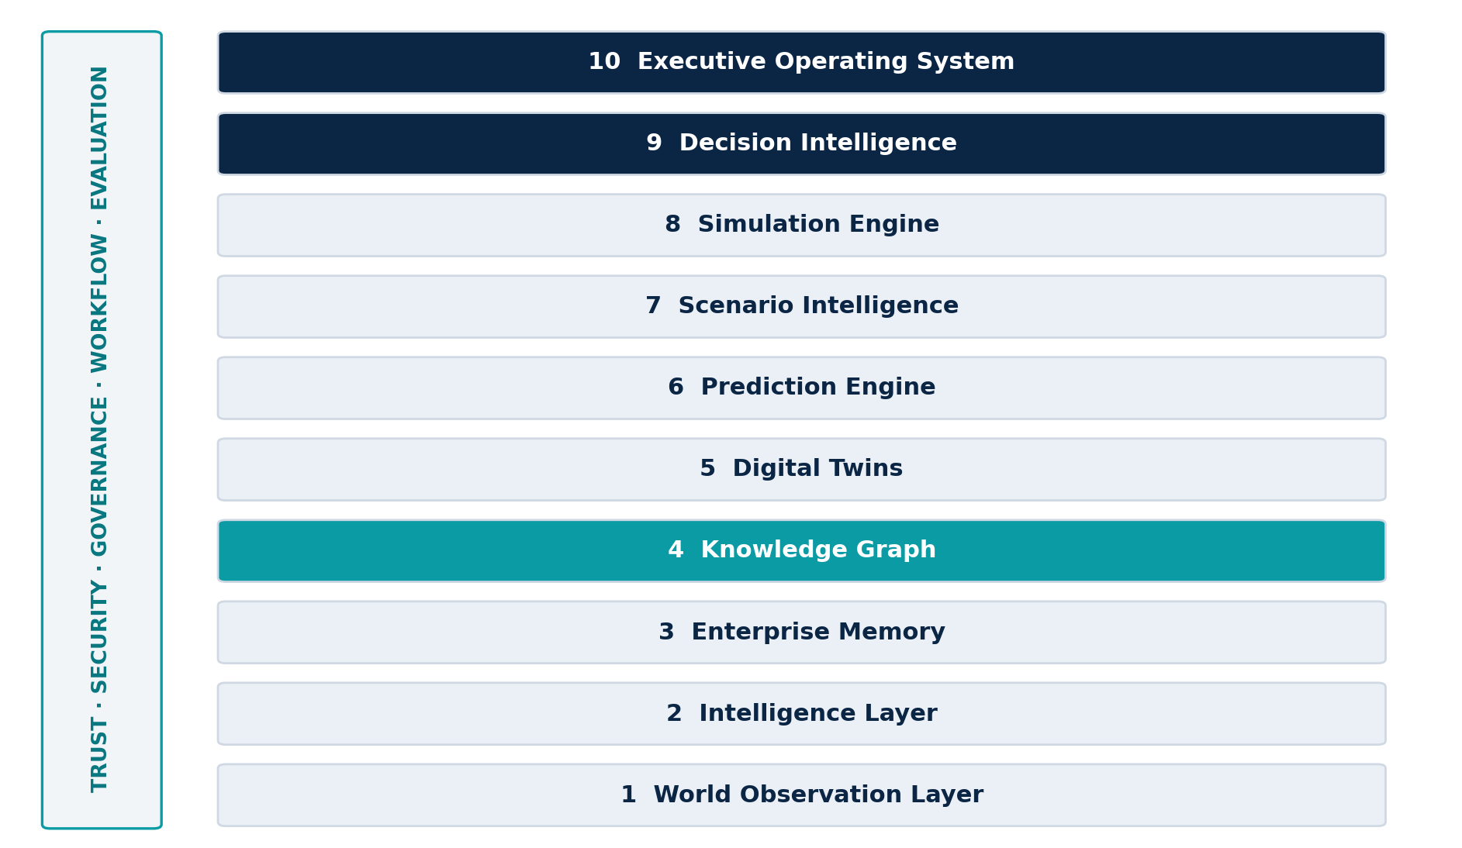
Figure 2. The ten-layer constitutional architecture with cross-cutting control planes.

Everything connects through governed meaning
Companies, countries, governments, products, technologies, people, supply chains, markets, regulations, events, risks, objectives, and capabilities create consequence through their relationships. The Knowledge Graph supplies stable identity, ontology, time, provenance, confidence, policy, and versioning so every layer refers to the same governed world without forcing one physical store.

Time is native to the graph
Strategic truth changes. The graph preserves event, valid, observation, and system-record time; reconstructs what was believed on a date; and separates later corrections from original state. This discipline makes Decision Replay, model evaluation, scenario comparison, and audit credible.

The Strategy Graph
The Strategy Graph connects objectives, assumptions, hypotheses, risks, opportunities, indicators, decisions, initiatives, capabilities, resources, owners, dependencies, commitments, and outcomes to external reality. It exposes change paths, affected objectives, accountable owners, and pending decisions.
CONSTITUTIONAL INHERITANCE / C-008 · C-009 · C-017

12 Digital Twins as Living Strategic Models
Digital Twins give the institution a versioned, evidence-grounded representation of the systems it must understand and influence.
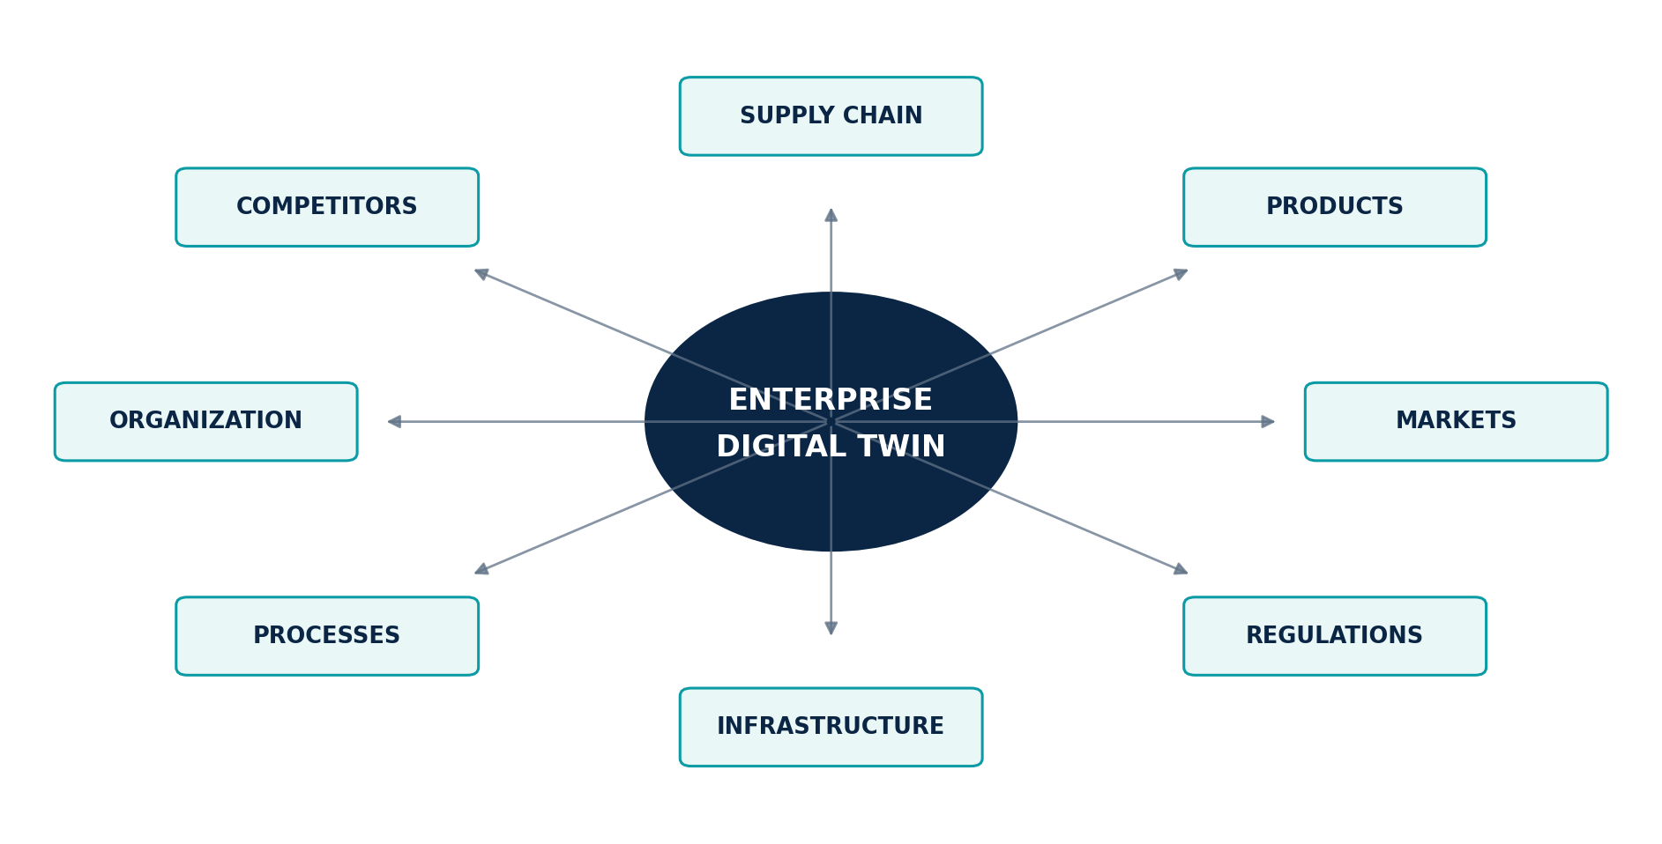
Figure 3. The living Digital Twin system around the enterprise.

A system of twins, not a single model
Every customer can maintain living Digital Twins for the company, competitors, supply chain, products, markets, regulations, infrastructure, business processes, and organization. Each twin declares its boundary, identity, state, relationships, behavior, evidence, assumptions, interfaces, controls, model dependencies, validation history, and known limitations. Synthetic state is clearly separated from observed state.

Grounding and versioning
A twin is only as valuable as its connection to evidence and its fitness for the decision being tested. The Eye tracks which sources support material state, when the state was valid, which transformations and models produced it, and whether the twin remains inside its validated operating envelope. Time travel, branching, replay, comparison, and reconciliation allow leaders to examine how the system evolved and why two simulations produced different results.

From representation to strategic experimentation
Digital Twins are grounded environments for testing scenarios and interventions before capital, authority, infrastructure, or lives are committed. They do not claim perfect replication: representations, assumptions, uncertainty, validation, and sensitivity remain inspectable so decision-makers can distinguish useful approximation from false precision.
CONSTITUTIONAL INHERITANCE / C-018 · C-019 · C-023

13 Prediction Across Six Horizons
The Prediction Engine maintains a portfolio of calibrated forecasts from immediate operational change to long-range strategic conditions.
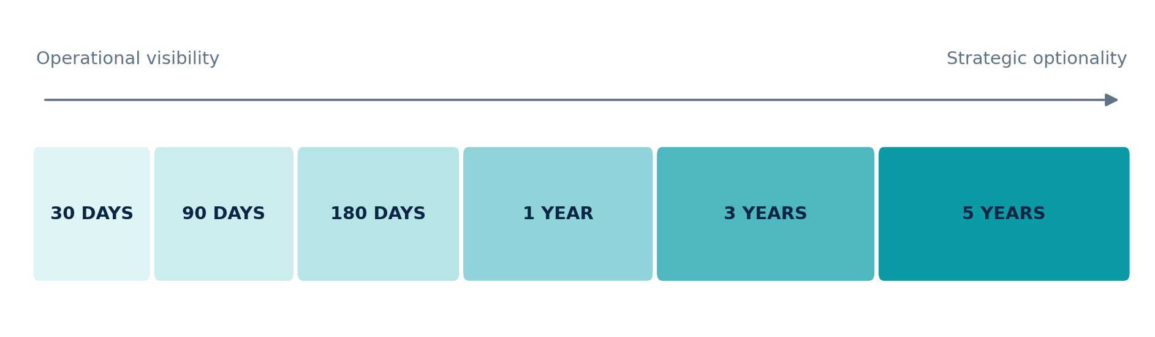
Figure 4. The six canonical prediction horizons.

Different horizons require different questions
Thirty-day forecasting is often dominated by current signals, known commitments, operational constraints, and short feedback loops. Five-year forecasting depends more heavily on structural drivers, technology trajectories, policy regimes, demographic and climate conditions, capability development, path dependence, and scenario uncertainty. The Eye supports 30-day, 90-day, 180-day, 1-year, 3-year, and 5-year horizons without pretending that one model or confidence language is appropriate to all of them.

Forecasts are distributions, not declarations
A material forecast communicates the outcome or state being estimated, its horizon, probability distribution, confidence, calibration, important drivers, assumptions, sensitivity, alternative models, failure conditions, provenance, and refresh cadence. The system maintains ensembles and specialist models where useful, compares performance by context and regime, and records when a model is operating outside the evidence on which it was validated.

Prediction serves decision, not spectacle
The purpose of a forecast is to improve timing, preparation, option value, and resource allocation. A forecast that cannot change a decision or monitoring posture may still be analytically interesting, but it should not consume executive attention. The Eye links forecasts to objectives, risks, opportunities, scenarios, decisions, and trigger conditions so leadership can see what action becomes rational as probability or consequence changes.
CONSTITUTIONAL INHERITANCE / C-020 · C-021 · C-049

14 Scenario Intelligence and the Discipline of Multiple Futures
Scenario Intelligence protects the institution from treating a preferred forecast as destiny by maintaining several coherent, monitored futures at once.

Coherent futures, not narrative decoration
A scenario is a governed strategic object with a baseline, initial conditions, drivers, assumptions, actors, events, uncertainties, indicators, branch points, interventions, impacts, owners, and review cadence. The Eye preserves a baseline, upside, downside, disruption, and customer-defined alternatives without assigning any one path the status of inevitable truth. Scenario quality is judged by coherence, decision relevance, evidence, differentiation, and monitoring value.

Living scenarios
Scenarios evolve as evidence changes. Leading indicators and branch conditions are connected to the World Observation Layer and Knowledge Graph. New events can increase or decrease scenario support, expose a previously unmodeled branch, or reveal that several scenarios share a hidden dependency. The platform preserves the history of those changes so leadership can see when the strategic view moved and why.

Strategy under uncertainty
The strongest strategic option is not always the option that performs best in the most likely scenario. It may be the option that preserves flexibility, limits irreversible downside, creates information, or remains viable across several futures. Scenario Intelligence allows the institution to compare robustness, regret, reversibility, trigger points, and option value rather than optimizing against a single assumed world.
SCENARIO PRINCIPLE
No single forecast may masquerade as destiny. The institution should be able to name the futures it is preparing for, the indicators it is watching, and the decisions that each future would change.
CONSTITUTIONAL INHERITANCE / C-022 · C-023 · C-026

15 Simulation Before Commitment
Simulation turns strategy from a verbal argument into a reproducible experiment conducted against declared models, assumptions, and constraints.

Testing interventions and shocks
The Simulation Engine applies policy changes, investments, operating decisions, adversarial actions, external shocks, timing choices, and combined interventions to versioned Digital Twins and scenarios. It estimates direct, indirect, delayed, systemic, distributional, and second-order effects. Multiple methods may be used, including system dynamics, agent-based simulation, discrete events, Monte Carlo methods, optimization, causal models, network propagation, and specialist domain engines.

Reproducibility is the basis of trust
Every material run declares the twin and scenario versions, initial state, assumptions, interventions, model versions, random seeds where applicable, constraints, outputs, sensitivity, and validation status. A decision-maker can reproduce the result, compare it with an alternative run, or identify exactly which changed assumption altered the conclusion. The platform never presents simulated output as observed fact.

Simulation informs judgment
A simulation does not decide. It exposes consequence under a declared representation of the world. The executive value lies in discovering nonlinear effects, hidden dependencies, timing sensitivity, downside concentration, information gaps, and actions that are robust across uncertainty. Human experts remain responsible for deciding whether the model is fit for the decision and whether unmodeled considerations change the choice.
- Compare interventions against a common baseline.
- Surface the assumptions carrying the result.
- Test sensitivity to timing, sequence, and adversarial response.
- Identify information whose acquisition would most improve the decision.
CONSTITUTIONAL INHERITANCE / C-018 · C-023 · C-024

16 Decision Intelligence and Accountable Choice
Decision Intelligence organizes evidence, objectives, alternatives, consequences, uncertainty, and authority around a specific human choice.
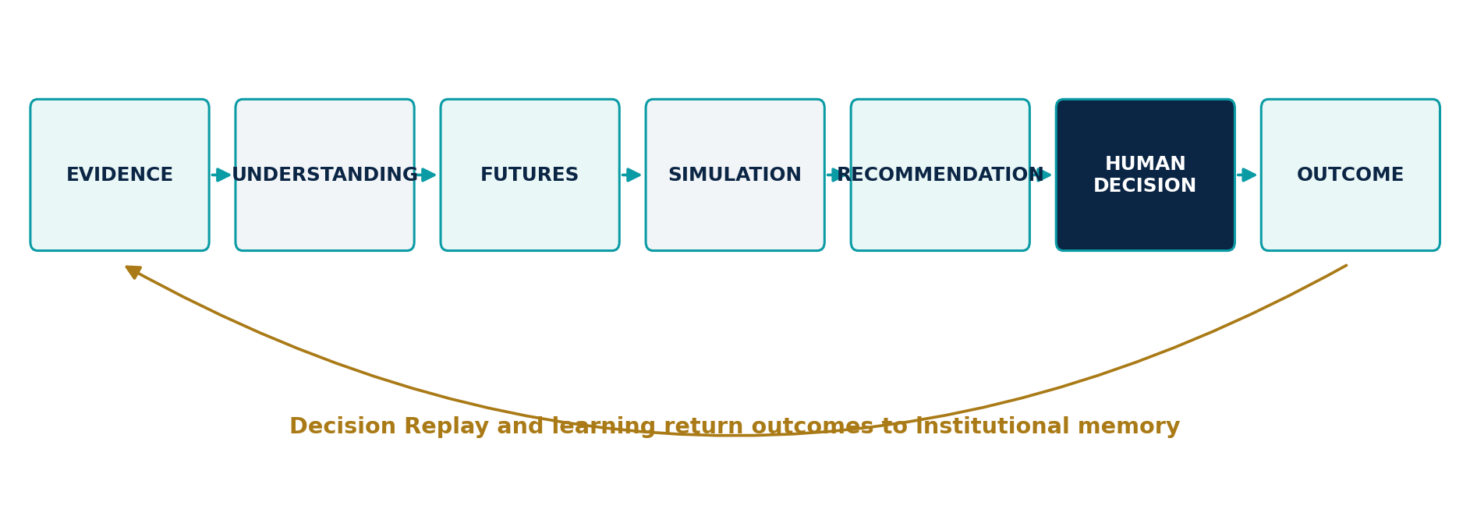
Figure 5. From evidence to accountable human decision and learning.

A complete decision package
The Eye compares viable options against declared objectives, stakeholder obligations, risk appetite, policy, constraints, dependencies, timing, reversibility, information value, and second-order effects. Each recommendation links to the evidence, forecasts, scenarios, simulations, assumptions, methods, and decision criteria that shaped it. Alternatives and dissent are retained. Missing information and model limitations are shown rather than absorbed into a score.

Authority, approval, and override
A decision record names the accountable authority, participants, required reviewers, approval state, commitments, monitoring conditions, and any override. The system can recommend a preferred option and explain why, but it cannot silently inherit decision rights from repeated use. Overrides are not treated as failure by default; they are evidence that must be examined against context and outcome.

The unit of institutional learning
Once a decision is made, the package becomes a forward-looking commitment: what the institution expected, which indicators would confirm or challenge the view, which actions were authorized, and when review should occur. Outcome data then returns to the same record. This makes the decision—not the report—the durable unit of strategic memory and evaluation.
CONSTITUTIONAL INHERITANCE / C-004 · C-005 · C-024

17 The Executive Operating System
The Executive Operating System is the decision-centered surface through which leadership governs strategic attention, commitments, review, and learning.

A workspace organized around responsibility
Executives should enter The Eye through objectives, material change, risks, opportunities, scenarios, pending decisions, commitments, and outcomes—not through the underlying database or model inventory. The workspace shows what changed since the last review, why it matters, which evidence and relationships support the assessment, who owns the response, and which decision window is closing.

Briefing as a live intelligence product
Executive briefings are generated from governed intelligence objects rather than copied into isolated documents. Every statement can be traced to current evidence and an as-of time. Changes since the prior briefing, disputed assessments, stale dependencies, emerging scenarios, required approvals, and monitoring triggers remain explicit. A briefing is a controlled view of the live system, not a terminal artifact.

Attention governance
The platform prioritizes by materiality, urgency, confidence, novelty, reversibility, strategic relevance, and required action. Users can inspect why an item was elevated, tune policy, suppress duplicates, delegate review, and see what was deprioritized. Engagement optimization is not the objective. The scarce resource being governed is executive attention.
OPERATING PRINCIPLE
Multiple interfaces may exist, but there is one governed strategic truth. Conversation is an interface, not the architecture.
CONSTITUTIONAL INHERITANCE / C-027 · C-032 · C-047

18 A Governed Society of AI Agents
Agents extend reach and parallelism inside The Eye; they do not create a second, unaccountable organization operating beside the enterprise.
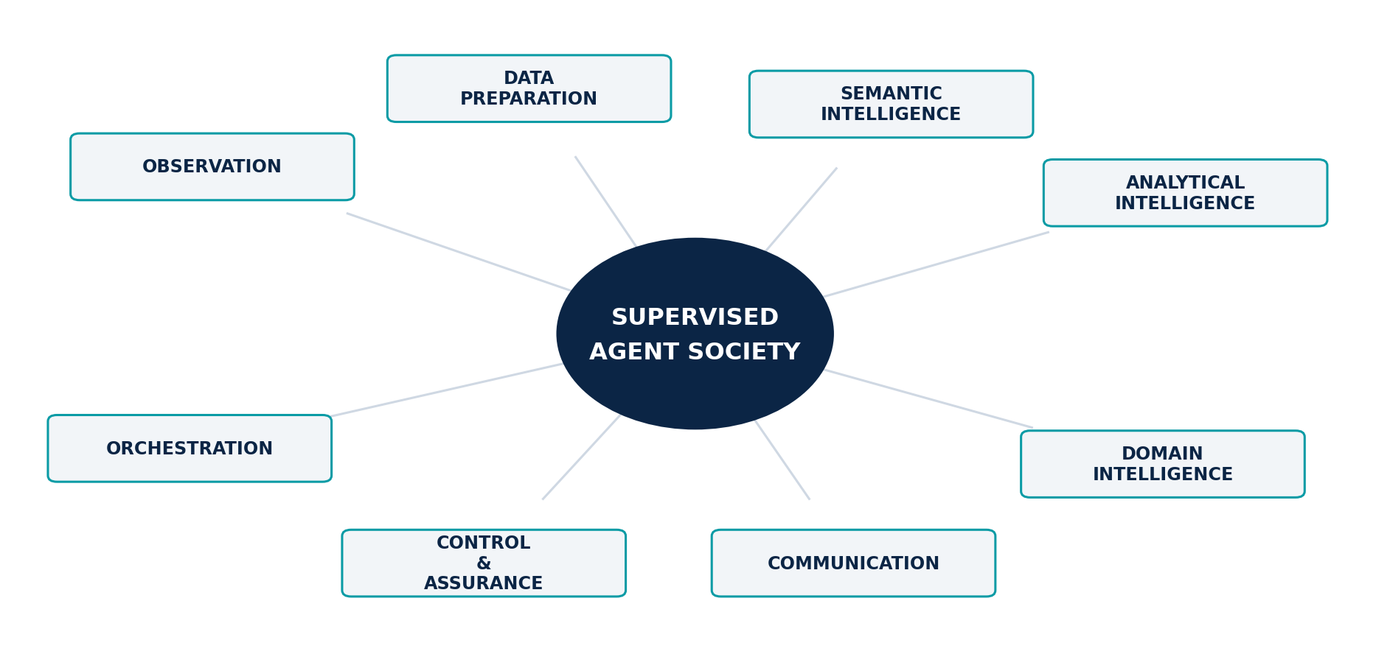
Figure 6. A supervised society of bounded agent families.

Specialized families, common governance
Governed families comprise: Observation, Crawler, Search, Collection; Cleaning, Classification, Summarization, NER, Relationship, Knowledge Graph; Reasoning, Prediction, Scenario, Simulation, Decision; Risk, Opportunity, Competitor, Supply Chain, Geopolitical, Technology, Cyber, Financial; Executive Briefing, Reporting; Governance, Learning; Planner, Supervisor, Workflow. Each agent declares purpose, owner, models, tools, permissions, scope, budgets, timeouts, evaluations, escalation, prohibitions, and rollback.

Orchestration and separation of duties
Planner agents decompose; Supervisors evaluate and route; Workflow agents govern state and recovery. High-impact work separates proposal, verification, approval, and release. Agents cannot self-authorize, approve exceptions, or turn recommendations into authority. External effects require explicit authorization, idempotency, audit, and containment.

Learning without silent self-modification
Agents may propose changes to prompts, tools, workflows, policies, ontologies, or models. Production changes require versioning, evaluation, security and policy review, approval, monitored release, and rollback. Continuous learning never permits silent self-modification.
AGENT CONTRACT
Every agent publishes remit, limits, evidence requirements, evaluation, stopping conditions, and accountable owner.
CONSTITUTIONAL INHERITANCE / C-028 · C-029 · C-030 · C-031

PART III
Strategic Outcomes and Executive Work
The operating capabilities through which The Eye converts connected intelligence into material advantage and institutional resilience.
THE EYE / THE OPERATING SYSTEM FOR STRATEGIC INTELLIGENCE

19 Proactive Intelligence and Weak Signals
The Eye must identify strategically material change before a user formulates the right question, while preserving evidence, attention, and human control.

From query response to persistent sensing
A question-led system is limited by what the institution already knows to ask. Strategic surprise often begins outside the established vocabulary: an unusual patent cluster, a change in regulatory language, a new supplier relationship, a subtle shift in hiring, a financing pattern, a scientific result, or a narrative moving across communities. The Eye continuously evaluates changes against objectives, capabilities, dependencies, risks, opportunities, and scenarios so intelligence can surface before it is requested.

Weak signals remain weak
Low-frequency or low-confidence evidence should not be promoted into certainty merely because it is novel. Weak Signal Detection records the observation, source quality, corroboration, related entities, potential mechanisms, scenario relevance, and conditions that would strengthen or falsify the signal. Multiple weak signals may form a pattern; an isolated anomaly may disappear. The product makes this evolution visible rather than rewriting the history after the fact.

Proactivity with attention policy
The system does not maximize notifications. It governs escalation through materiality, urgency, novelty, confidence, persistence, strategic proximity, and required action. Users can see why an item was elevated, which policy was applied, and what was suppressed or deferred. This prevents proactive intelligence from becoming an automated source of executive noise.
PROACTIVE INTELLIGENCE
Surface material changes, weak signals, risks, and opportunities before users ask—without sacrificing provenance, authority, or attention discipline.
CONSTITUTIONAL INHERITANCE / C-032 · C-033 · C-047

20 Early Warning with Context
An early warning is useful only when leadership understands what changed, why it matters, how certain the assessment is, and what response window remains.

Warnings are governed intelligence products
The Early Warning System combines weak signals, leading indicators, source events, forecast revisions, threshold breaches, graph changes, twin degradation, scenario movement, and model-detected anomalies. Every warning identifies the affected objectives, assets, decisions, geographies, actors, and time horizons. It links to supporting and contradicting evidence, declares confidence, and separates the observed condition from the system's interpretation.

Deduplication and prioritization
Several sources may describe the same underlying event, while one event may create multiple consequences. The Eye clusters related evidence without losing source independence, establishes whether signals share a common cause, and prevents repeated alerts from masquerading as corroboration. Priority reflects consequence and decision relevance, not merely volume or recency.

Warnings connect to response
Each material warning can trigger a governed response playbook: request verification, commission analysis, refresh a forecast, branch a scenario, run a simulation, convene a decision room, protect an option, or monitor a defined indicator. Time bounds, owners, escalation rules, and closure criteria are explicit. The institution can later evaluate whether the warning was timely, calibrated, actionable, and proportionate.
- Evidence-backed and confidence-aware.
- Linked to objectives, assets, scenarios, and decisions.
- Time-bounded with owners and response playbooks.
- Evaluated for misses, false positives, latency, and consequence.
CONSTITUTIONAL INHERITANCE / C-014 · C-032 · C-033

21 Risk and Opportunity Are Symmetric
The same world change can create exposure for one objective and advantage for another; strategic intelligence must evaluate both sides of the change.

Beyond defensive risk registers
Traditional risk processes often begin with a fixed taxonomy and focus on loss prevention. The Eye begins with objectives and models how external events, internal conditions, dependencies, and decisions alter the probability or value of outcomes. Risk includes exposure, likelihood, impact, velocity, persistence, controllability, reversibility, concentration, and interdependence. It is continuously connected to evidence and scenario state rather than reviewed as a static list.

Opportunity is governed with equal discipline
Opportunities require the same rigor as threats. The platform evaluates strategic fit, addressable value, timing, required capabilities, dependencies, competitive response, regulatory conditions, investment, downside, learning value, and option value. An attractive signal is not automatically an opportunity; it becomes one when the institution can explain how the change creates a plausible path to an objective.

Choices combine mitigation and exploitation
One action may reduce downside while preserving upside. Another may protect the institution at the cost of strategic flexibility. The Eye makes those trade-offs explicit, compares intervention portfolios across scenarios, and shows which actions are no-regret, reversible, contingent, or irreversible. Leadership can govern risk appetite and opportunity appetite within the same decision architecture.
STRATEGIC SYMMETRY
Every material change should be assessed for what it can damage, what it can enable, which options it creates or destroys, and how quickly the institution must decide.
CONSTITUTIONAL INHERITANCE / C-024 · C-026 · C-032

22 Domain Intelligence as One Connected World
Competitor, market, geopolitical, regulatory, technology, cyber, and financial intelligence are specialist lenses over one shared reality—not separate universes.

Specialist depth without semantic isolation
Domain agents and expert workflows apply the sources, ontologies, models, methods, policy, and evaluation required by their field. Competitor Intelligence tracks positioning, capabilities, products, partnerships, talent, capital, and intent. Geopolitical Intelligence connects states, alliances, conflict, sanctions, trade, resources, and national policy. Technology Intelligence evaluates maturity, diffusion, dependencies, patents, research, and adoption. Cyber and Financial Intelligence contribute threat, exposure, market, liquidity, and counterparty views.

Cross-domain effects create strategic consequence
A technology may be commercially attractive, strategically sensitive, dependent on concentrated supply, exposed to export control, targeted by cyber actors, and financed by competitors operating under different policy regimes. The Knowledge Graph allows each specialist assessment to retain its methods while connecting the consequences. Leadership sees one strategic system instead of reconciling several domain reports after the fact.

Shared evidence, explicit methods
Specialist conclusions remain traceable to sources, method versions, assumptions, confidence, and accountable review. Shared entities and events prevent duplicated collection and contradictory identifiers. Domain-specific extensions can enrich the ontology and model suite without redefining foundational concepts. This creates a common language for cross-functional strategy while protecting professional standards.
- Competitor and market position.
- Geopolitical and regulatory operating space.
- Technology maturity and dependency.
- Cyber threat and strategic vulnerability.
- Financial exposure, liquidity, and counterparty conditions.
CONSTITUTIONAL INHERITANCE / C-007 · C-009 · C-030

23 Supply Chain and Operational Resilience
The Eye treats the supply chain as a living network of entities, dependencies, capacities, obligations, routes, policies, and failure modes—not a static supplier list.

A connected dependency model
The Supply Chain Twin links suppliers, sub-tier suppliers, components, materials, facilities, routes, ports, logistics providers, inventories, lead times, certifications, contracts, jurisdictions, sanctions, weather, infrastructure, and demand. It exposes concentration hidden behind direct relationships and shows how a single dependency participates in several products, markets, and customer commitments.

From disruption alert to consequence
When a facility closes, a route degrades, a regulation changes, or a supplier weakens, The Eye propagates the event through the graph and twin. It estimates affected products, revenue, customers, obligations, alternatives, recovery time, and strategic options. Forecasts and simulations compare rerouting, substitution, inventory allocation, qualification, nearshoring, contract action, and demand shaping under declared assumptions.

Resilience as an executive choice
Resilience is not maximum redundancy. It is the deliberate balance of cost, concentration, recovery, sovereignty, flexibility, quality, and strategic importance. The Eye makes that balance visible and monitors whether the chosen posture remains inside policy. Leadership can distinguish temporary operational friction from a structural dependency that changes the enterprise strategy.
RESILIENCE PRINCIPLE
The institution should know which dependencies can interrupt an objective, how quickly consequence propagates, which alternatives are real, and what action preserves the greatest option value.
CONSTITUTIONAL INHERITANCE / C-017 · C-018 · C-043

24 The Strategic Health Score
The Strategic Health Score provides a compact, explainable view of readiness and exposure without reducing the enterprise to an unexplained grade.

A composite view anchored in objectives
The score can organize measures across capabilities, operations, finance, technology, people, supply chain, markets, regulation, cyber, geopolitics, and other domains relevant to the institution. Components are linked to objectives, baselines, thresholds, evidence, freshness, owners, and decision relevance. The score does not compete with the underlying analysis; it provides an entry point into it.

Every component remains inspectable
Weights, normalization, confidence, sensitivity, trend, peer comparison, model version, data quality, and missing coverage are visible. Users can see which component moved the score, which evidence supports the movement, how alternative weights change the view, and whether the score is stable across plausible assumptions. A red or green status never substitutes for explanation.

Health is directional and decision-linked
A strong current condition may hide a weakening trajectory. A weak condition may be improving fast enough to protect a future commitment. The Eye therefore emphasizes movement, persistence, uncertainty, and strategic consequence. Score changes can trigger investigation, scenario review, or decision workflows; they do not automatically authorize action.
SCORE PRINCIPLE
A strategic health measure must decompose into evidence, components, weights, confidence, trend, sensitivity, and the decisions it is intended to inform.
CONSTITUTIONAL INHERITANCE / C-034 · C-047 · C-049

25 Decision Replay and Institutional Learning
Decision Replay reconstructs what the institution knew, believed, simulated, recommended, and decided at the time—then compares that record with what happened.

Learning without hindsight distortion
A later outcome can make an earlier choice look obvious or irrational when the original uncertainty is forgotten. The Eye preserves the historical evidence set, graph version, twin state, forecasts, scenarios, simulations, recommendations, alternatives, dissent, policy, approvals, and information gaps available at decision time. Replay allows the institution to evaluate process and judgment without rewriting the record around the outcome.

Separate decision quality from outcome luck
A sound decision can produce a poor outcome because an unlikely event occurred; a weak process can produce a favorable outcome by chance. Decision Replay compares calibration, assumptions, information use, option framing, timing, policy compliance, execution, and monitoring. It identifies whether the error came from observation, interpretation, model, scenario coverage, simulation, recommendation, human judgment, action, or external change.

Lessons become governed assets
A lesson is not an anecdote. It states the reviewed conclusion, evidence, applicable context, owner, validity, and expected change to policy, sources, ontology, models, workflows, thresholds, or training. Lessons are versioned and can expire when operating conditions change. This prevents institutional memory from hardening one historical experience into an unqualified rule.
- Reconstruct the original decision environment.
- Evaluate forecast, simulation, process, and execution separately.
- Preserve dissent and override as evidence.
- Release improvements through governed learning controls.
CONSTITUTIONAL INHERITANCE / C-011 · C-025 · C-044

26 The Strategy Graph and Organizational Alignment
The Strategy Graph converts strategy from a collection of presentations into a governed network of objectives, assumptions, decisions, capabilities, commitments, and outcomes.

Strategy becomes inspectable
Objectives are connected to owners, measures, time horizons, assumptions, dependencies, risks, opportunities, capabilities, initiatives, resources, decisions, and expected outcomes. External events and internal state can reach those objects through the Knowledge Graph. Leadership sees not only whether a metric moved, but which strategic claim or commitment the movement challenges.

Alignment is a relationship problem
Organizations often declare aligned objectives while funding, incentives, capabilities, and decisions point in different directions. The Strategy Graph reveals contradictions, orphaned initiatives, unsupported objectives, duplicated capabilities, dependency bottlenecks, and decisions without accountable owners. Alignment can be evaluated continuously rather than inferred from the consistency of language in planning documents.

Change propagates through intent
When a strategic assumption fails, the system identifies affected scenarios, forecasts, initiatives, investment decisions, commitments, and review owners. When an objective changes, downstream priorities and monitoring logic can be reassessed without losing their earlier history. This gives the enterprise a controlled way to adapt strategy while preserving accountability for what changed.
ALIGNMENT PRINCIPLE
A strategy is operational when every material objective can be traced to evidence, assumptions, capabilities, decisions, owners, commitments, and outcomes.
CONSTITUTIONAL INHERITANCE / C-017 · C-026 · C-027

27 A Strategic Cadence from Daily Signals to Five-Year Choices
The Eye connects the institution's operating cadence so immediate change and long-range strategy are reviewed through the same system of record.

Daily and event-driven orientation
Daily operation focuses on material changes, weak signals, early warnings, source coverage, emerging dependencies, and decisions whose window is closing. Event-driven workflows convene the right owners when thresholds, scenarios, forecasts, or policy conditions change. The system records what was reviewed, what was delegated, and why an item was dismissed or escalated.

Weekly and monthly governance
Weekly forums examine movement across objectives, risks, opportunities, scenarios, commitments, and intelligence quality. Monthly or quarterly reviews evaluate strategic health, forecast calibration, decision progress, cross-functional dependencies, learning, and portfolio change. The live system replaces the ritual of rebuilding context for each meeting while preserving formal governance where it adds authority.

Annual and multi-year strategy
Long-range planning uses the same evidence, graph, twins, horizons, scenarios, and decision history as the operating cadence. Five-year choices can be monitored through near-term indicators and reviewed as assumptions evolve. The institution can distinguish a strategy that remains valid from one that survives only because its assumptions are no longer visible.
CADENCE PRINCIPLE
Strategic continuity is achieved when daily sensing, executive review, portfolio governance, annual planning, and multi-year commitments operate on the same connected memory.
CONSTITUTIONAL INHERITANCE / C-020 · C-027 · C-032

PART IV
Enterprise Value Across Sectors
A universal strategic intelligence core, expressed through the missions, operating models, policies, and decisions of each institution.
THE EYE / THE OPERATING SYSTEM FOR STRATEGIC INTELLIGENCE

28 Governments and Defence
Governments and defence organizations require strategic intelligence that integrates national objectives, policy, capabilities, threats, alliances, infrastructure, industry, and public consequence under strict authority and sovereignty.

A whole-of-system view
The Eye can connect diplomatic, economic, technological, industrial, regulatory, security, environmental, and societal signals to national objectives and mission capabilities. Knowledge Graphs and Digital Twins represent actors, institutions, assets, dependencies, geography, logistics, policy, and strategic intent. Scenario Intelligence explores competing futures and adversarial action; simulation tests readiness, policy options, force or resource allocation, and infrastructure consequence.

Authority and classification by design
Government and defence deployments may require multi-classification operation, sovereign infrastructure, disconnected environments, restricted model use, customer-controlled cryptography, compartmented data, and mission-specific audit. The same semantic and decision architecture must function within those constraints. Agents remain bounded, human command authority remains explicit, and every material recommendation retains provenance and policy state.

Institutional memory across administrations and missions
Strategic context often spans political cycles, postings, operations, procurements, and leadership transitions. Strategic Memory preserves why policies and commitments were made, which warnings were available, how assumptions changed, and what outcomes followed. This continuity supports accountability without locking future leaders into past judgment.
ILLUSTRATIVE MISSION OUTCOMES
Earlier warning, stronger policy coherence, resilient national capabilities, explainable resource choices, governed multi-domain analysis, and durable strategic memory.
CONSTITUTIONAL INHERITANCE / C-004 · C-041 · C-043

29 Financial Institutions and Healthcare
Banks and healthcare institutions operate under different missions, yet both require high-integrity intelligence where uncertainty, regulation, human consequence, and system resilience are inseparable.

Banks and financial institutions
For banks, The Eye connects markets, counterparties, sectors, jurisdictions, sanctions, regulation, liquidity, technology, cyber risk, supply networks, climate exposure, and customer conditions. It can model concentration beyond direct holdings, monitor scenario movement, evaluate strategic options, and preserve the basis for risk and capital decisions. Recommendations remain explainable and policy-bound; high-impact decisions affecting credit or essential access remain under explicit human authority.

Healthcare and life sciences
For healthcare, the platform connects scientific evidence, clinical operations, public health, supply, regulation, workforce, infrastructure, technology, population conditions, and strategic investment. Digital Twins can represent capacity, pathways, assets, markets, or product systems; scenarios and simulations can test demand, disruption, allocation, and policy. The platform supports institutional decisions without replacing clinical judgment or determining an individual's rights or care autonomously.

A shared requirement for trust
Both sectors require purpose limitation, minimization, granular access, explainability, audit, temporal accuracy, model evaluation, human review, resilience, and lawful operation. The Eye's value is not simply better prediction. It is the combination of foresight with the controls required to use foresight responsibly in regulated, high-consequence environments.
ILLUSTRATIVE OUTCOMES
Connected exposure, calibrated forecasts, scenario-tested strategy, resilient operations, explainable recommendations, and auditable human decisions.
CONSTITUTIONAL INHERITANCE / C-005 · C-040 · C-050

30 Manufacturing, Energy, and Critical Infrastructure
Industrial strategy depends on understanding how markets, technology, assets, suppliers, regulation, capital, energy, and geopolitics interact across long investment cycles.

Manufacturing as a connected strategic system
The Eye connects product portfolios, plants, equipment, workforce, suppliers, materials, customers, quality, inventory, logistics, patents, competitors, technology trajectories, incentives, trade policy, and demand. Digital Twins represent the enterprise and its production network; forecasts and scenarios test capacity, sourcing, product transition, automation, geographic exposure, and investment timing. Executive decisions can be evaluated against margin, resilience, sovereignty, growth, and capability objectives together.

Energy and infrastructure
Energy and infrastructure decisions combine asset life, reliability, demand, market design, regulation, climate, technology, permitting, public policy, supply, capital, and geopolitical exposure. The Eye supports long-horizon scenario portfolios and near-term operational sensing within one memory. Simulation can examine outages, demand shifts, price regimes, transition pathways, maintenance choices, and cascading network effects under explicit assumptions.

From asset visibility to strategic optionality
Operational data becomes strategically useful when it is connected to external conditions and future choices. A maintenance event may change capacity; a regulation may change asset value; a technology shift may change the investment thesis. The platform makes those relationships visible early enough for the institution to preserve options rather than react after capital is committed.
ILLUSTRATIVE OUTCOMES
Resilient capacity, better capital timing, connected technology intelligence, supply assurance, scenario-tested transition, and faster response to structural change.
CONSTITUTIONAL INHERITANCE / C-018 · C-020 · C-026

31 Logistics, Telecom, and Retail Networks
Network businesses win by detecting change early, understanding propagation, allocating capacity intelligently, and preserving service under disruption.

Logistics
For logistics, the platform connects routes, ports, carriers, facilities, capacity, demand, weather, infrastructure, regulation, customs, security, fuel, customers, and supply-chain dependencies. Live observation and Digital Twins support rerouting, capacity planning, disruption response, and investment. Scenario Intelligence distinguishes transient congestion from structural shifts in trade, policy, geography, and customer networks.

Telecom
For telecom operators, The Eye connects infrastructure, vendors, spectrum, regulation, demand, cyber conditions, technology roadmaps, service quality, capital plans, energy, and national policy. The system can model dependency, modernization, vendor concentration, outage propagation, competitive moves, and strategic technology choices while preserving security and sovereignty constraints.

Retail and consumer networks
Retail requires connected views of customers, products, suppliers, inventory, channels, competitors, pricing, locations, regulation, economic conditions, and social signals. The Eye can identify emerging demand, expose supply or margin risk, simulate assortment and network choices, and separate short-lived noise from sustained behavior. Customer-level automated decisions remain governed by applicable rights and human-authority boundaries.
ILLUSTRATIVE OUTCOMES
Faster disruption response, smarter capacity and network investment, earlier demand recognition, connected competitor intelligence, and resilient customer commitments.
CONSTITUTIONAL INHERITANCE / C-007 · C-013 · C-043

32 Fortune 500, Consulting, and SMEs
The Eye scales from global federated enterprises to focused managed deployments without changing the strategic loop, trust model, or core semantics.

Global enterprises
Fortune 500 organizations can use The Eye to connect business units, regions, portfolios, capabilities, markets, suppliers, regulations, investments, and enterprise objectives. Federated data ownership allows domains to preserve accountability while the platform supplies shared identity, policy, provenance, workflow, and semantics. Leadership receives an enterprise view without creating an uncontrolled central replica of every system.

Consulting and professional services
Consulting organizations can build governed client-specific knowledge, scenario, model, and workflow environments while preserving confidentiality and methodological traceability. The platform supports research, hypothesis management, evidence comparison, client Digital Twins, strategic option analysis, executive communication, and Decision Replay. Reusable domain packs can transfer method without transferring private client knowledge.

Small and medium-sized enterprises
SMEs face strategic exposure with fewer specialized teams. A managed configuration can provide a narrower field of view, curated sources, preconfigured domain intelligence, guided workflows, and proportional governance. The product becomes simpler through configuration and experience design—not by removing provenance, human authority, security, or the ability to retrieve the institution's own knowledge.
SCALE PRINCIPLE
The scope and operating model may change by customer size. The intelligence lifecycle, constitutional boundaries, and standard of accountability do not.
CONSTITUTIONAL INHERITANCE / C-006 · C-007 · C-037

33 One Core, Governed Specialization
Universal applicability is achieved through a stable domain-neutral core and governed extensions—not through a lowest-common-denominator product.

The common substrate
Every customer shares foundational objects: sources, evidence, entities, events, claims, relationships, objectives, risks, opportunities, capabilities, indicators, hypotheses, forecasts, scenarios, simulations, recommendations, decisions, actions, outcomes, and lessons. Shared semantics allow platform services, governance, evaluation, and experience patterns to operate consistently across sectors.

Domain packs
Sectors and customers can add ontology extensions, source connectors, policies, metrics, twin templates, model suites, agent capabilities, workflows, simulation methods, executive views, and evaluation sets. Each extension declares namespace, purpose, owner, evidence requirements, permissions, compatibility, evaluation, licensing, lifecycle, and relationship to core terms. Extensions may enrich the system; they may not fork its constitutional meaning.

Transfer capability, not private knowledge
The Eye can improve the platform through better software, methods, models, evaluation, and governed packages without pooling customer data or strategic memory by default. Tenant isolation and contractual authority govern any contribution to shared learning. This architecture creates compounding platform capability while protecting sovereignty and trust.
- Stable canonical semantics across all customers.
- Governed namespaces for domain and customer extensions.
- Explicit compatibility and evaluation contracts.
- No cross-tenant learning without authority and technical separation.
CONSTITUTIONAL INHERITANCE / C-006 · C-007 · C-044

PART V
Trustworthy Enterprise Operation
The controls that make strategic intelligence explainable, sovereign, secure, deployable, evaluable, and fit for long-term institutional use.
THE EYE / THE OPERATING SYSTEM FOR STRATEGIC INTELLIGENCE

34 Trust, Provenance, and Explainability
Trust in The Eye is not a confidence badge. It is the inspectable chain connecting source, transformation, inference, review, recommendation, decision, action, and outcome.

The trust envelope
Every material intelligence object carries identity, source references, chain of custody, truth state, temporal state, classification, sensitivity, usage rights, transformation lineage, model and agent versions, confidence, quality, policy decisions, human review, expiry, limitations, and correction history appropriate to its role. Trust is therefore distributed through the object model and control planes rather than added as a downstream compliance label.

Provenance in both directions
A decision-maker can trace a recommendation backward through criteria, simulations, scenarios, forecasts, twin state, graph claims, transformations, and original evidence. The reverse path is equally important: when a source is corrected, withdrawn, or compromised, the system can identify every downstream object, briefing, recommendation, and decision potentially affected. This bidirectional provenance turns trust into an operational capability.

Explanation is decision-specific
An executive requires the basis, material drivers, alternatives, uncertainty, and consequence. An analyst requires methods, evidence, graph context, model behavior, sensitivity, and competing hypotheses. An auditor requires lineage, identity, approval, policy, and version history. The Eye layers explanation without hiding facts that could change a reasonable decision. Protected internal chain-of-thought is not the governing standard; reproducible evidence paths and concise reasoning summaries are.
TRUST PRINCIPLE
Every recommendation must be explainable in the context of the decision, traceable to original evidence, and attributable to the models, agents, reviewers, and policies that shaped it.
CONSTITUTIONAL INHERITANCE / C-005 · C-012 · C-035 · C-036

35 Security, Privacy, Sovereignty, and Resilience
The Eye will hold an institution's most sensitive evidence, models, assumptions, intentions, and decisions; protection of strategic context is therefore part of the product itself.

Zero-trust strategic infrastructure
Every person, service, device, workload, connector, source, model, agent, and deployment component has verifiable identity and scoped authority. Access decisions combine role, attributes, purpose, tenant, classification, policy, device and workload posture, network context, and risk. Authorization is continuous. Network location alone is never treated as trust.

Protection extends beyond data
Encryption, customer-managed keys where required, secrets isolation, field- and row-level controls, secure deletion, backup protection, exfiltration controls, and confidential-computing options protect data. Models, prompts, ontologies, agent definitions, twin states, scenarios, simulation configurations, Strategy Graphs, and decision records are equally sensitive assets. Supply-chain security, prompt injection, data poisoning, insecure tool use, model extraction, privilege escalation, and manipulated feedback are addressed as first-class threats.

Privacy and sovereign control
Personal and sensitive information is purpose-bound, minimized, policy-enforced, and retained only under applicable authority. The graph supports policy on relationships because sensitive inference can arise from connection rather than a single field. Customers control residency, encryption, model choice, administrative boundaries, exports, retention, and deletion within the selected deployment mode.

Resilience with visible degradation
The platform is designed for containment, redundancy, backup, restore, cyber recovery, dependency failure, model outage, connector degradation, and disconnected operation. When freshness, provenance, model availability, coverage, or policy services are impaired, the user sees the condition and the system restricts actions accordingly. A graceful interface that hides degraded intelligence is a product failure.
CONSTITUTIONAL INHERITANCE / C-039 · C-040 · C-041 · C-043

36 Three Deployment Modes, One Product
SaaS, Private Cloud, and On-Premise are first-class operating modes of one Strategic Intelligence Operating System—not separate products with different meanings.
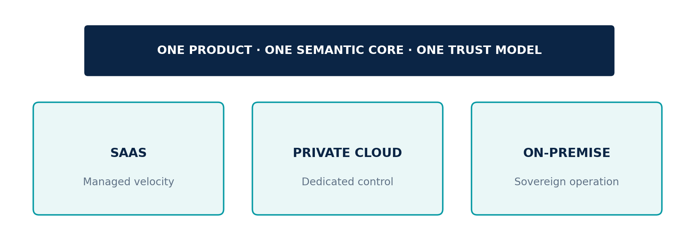
Figure 7. Semantic parity across all three deployment modes.

SaaS
The managed service provides the fastest path to continuous operation, platform updates, shared reliability engineering, and scalable source and model integration. Tenant isolation, residency, encryption, portability, policy, audit, and customer control remain explicit. Managed convenience never changes ownership of customer knowledge or decision authority.

Private Cloud
A dedicated cloud environment supports customer-specific networks, identity, keys, regions, integrations, models, controls, observability, and operating responsibilities. The mode is appropriate where institutional separation, regulatory posture, performance, or sovereign control requires a dedicated boundary while retaining cloud operating characteristics.

On-Premise
Customer-controlled data-center, edge, sovereign, or disconnected environments support local administration, local inference options, offline update paths, customer-controlled telemetry, and operation without a mandatory external service. Core decision workflows remain functional within the declared operating boundary.

Semantic parity
Core objects, APIs, provenance, policy, agent contracts, workflows, model interfaces, twin packages, scenarios, decisions, audit, and user concepts remain consistent across modes. Differences in topology and managed services are declared as capability constraints, never hidden fragmentation.
CONSTITUTIONAL INHERITANCE / C-038 · C-041 · C-042

37 Continuous Learning with Continuous Evaluation
The Eye learns from outcomes, corrections, overrides, and new evidence through governed release processes—not by silently converting every interaction into truth.

The learning loop
The system captures the original observation, forecast, scenario, simulation, recommendation, human decision, action, and measurable outcome. It evaluates performance against explicit baselines and segments results by context, horizon, domain, confidence, and operating regime. Errors are diagnosed across sources, ontology, extraction, retrieval, reasoning, model, twin, assumption, workflow, policy, interface, and human use.

Improvement is a versioned proposal
Changes to prompts, models, tools, agents, ontologies, thresholds, workflows, policies, and decision logic are proposed with expected benefit, risk, evidence, test plan, compatibility impact, and rollback path. They are evaluated offline and in controlled environments for regression, calibration, robustness, security, privacy, bias, latency, cost, and operator burden before progressive release.

Feedback is evidence, not truth
User ratings, acceptance, overrides, corrections, and outcomes are important signals, but they can reflect incentives, fatigue, incomplete information, politics, or misuse. Feedback retains source, role, context, and consequence. It is evaluated before changing production behavior. Popularity never substitutes for validity or responsible use.

Tenant isolation in learning
Customer data and feedback are not used to improve shared models or other tenants without explicit authority, legal basis, contractual permission, and technical separation. Federated or privacy-preserving approaches may be supported, but participation, contribution, and resulting model lineage remain inspectable.
CONSTITUTIONAL INHERITANCE / C-031 · C-044 · C-045

38 Governed Marketplaces and a Strategic Ecosystem
The Scenario Marketplace and Agent Marketplace allow the platform to compound capability without relaxing trust, sovereignty, or accountability.

The Agent Marketplace
Approved agents, tools, workflows, and domain capabilities can be discovered and deployed as governed packages. Each package declares publisher, purpose, permissions, model dependencies, data use, evaluation evidence, compatibility, cost, limitations, licensing, update policy, and revocation. Installation and activation remain under customer policy; execution is sandboxed and observable.

The Scenario Marketplace
Scenario frameworks, indicators, models, assumptions, actor structures, and monitoring logic can be packaged for reuse. A customer can begin with a validated domain framework, calibrate it to local evidence and objectives, and preserve the resulting instance as private strategic memory. Marketplace quality is established by method fitness, evidence, validation, maintenance, and publisher accountability—not by popularity alone.

Ecosystem without semantic drift
Packages are signed, versioned, licensed, permission-scoped, evaluated, inspectable, monitored, revocable, and traceable. Compatibility contracts preserve the canonical object model and constitutional boundaries. The marketplace can expand sector depth and customer choice while preventing extensions from becoming uncontrolled shadow platforms.
MARKETPLACE PRINCIPLE
The ecosystem may extend capability, but it cannot bypass identity, policy, provenance, evaluation, sandboxing, customer control, or human authority.
CONSTITUTIONAL INHERITANCE / C-028 · C-038 · C-046

39 Adoption, Value, and Strategic Maturity
The Eye becomes an operating system through institutional adoption: shared objects, decision workflows, governance, and learning—not through the deployment of another isolated application.
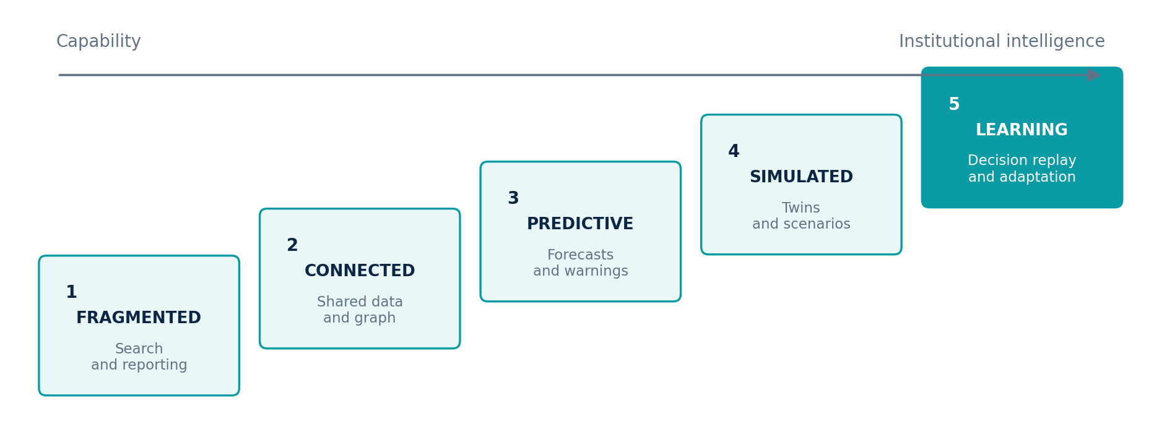
Figure 8. The path from fragmented information to a learning strategic system.

Begin with consequential decisions
Adoption anchors on decisions whose quality, speed, continuity, or accountability materially affects the institution. Sources, graph scope, twins, models, agents, scenarios, and workflows organize around those decisions. This creates a measurable line from platform capability to executive value and prevents open-ended integration.

Build the shared strategic substrate
The institution establishes canonical identities, decision records, source contracts, provenance, access policy, truth states, time semantics, and ownership. Existing systems remain connected; domain teams retain responsibility for meaning and quality; shared control and semantic services enable enterprise intelligence.

Measure maturity through behavior
Maturity advances when evidence becomes traceable, relationships shared, forecasts calibrated, scenarios monitored, simulations reproducible, decisions complete, outcomes connected, and lessons govern future behavior. Deployment size is not maturity; the measure is whether the institution can observe, understand, predict, simulate, decide, and learn as one system.

Value is multidimensional
Value is measured through detection and understanding latency, decision cycle time, forecast calibration, warning precision, scenario coverage, prevented loss, captured opportunity, preserved option value, resilience, auditability, attention saved, and learning applied. Every measure links to the decision and objective it serves.
CONSTITUTIONAL INHERITANCE / C-006 · C-027 · C-049

PART VI
The Strategic Intelligence Enterprise
The long-horizon end state: an institution that senses continuously, reasons coherently, decides accountably, and learns across generations of leadership.
THE EYE / THE OPERATING SYSTEM FOR STRATEGIC INTELLIGENCE

40 The Strategic Intelligence Enterprise
The end state is not an organization with more AI. It is an organization whose strategic intelligence operates as durable institutional infrastructure.

A persistent model of the world and the institution
The Strategic Intelligence Enterprise maintains a living, governed representation of its environment, itself, its objectives, and the relationships that shape consequence. External change is connected to internal capability and strategic intent. Evidence, models, assumptions, decisions, actions, and outcomes remain part of one memory. Leadership does not begin each decision by reconstructing reality from disconnected systems.

Human judgment amplified by machine reach
Agents observe, collect, compare, model, monitor, forecast, simulate, and prepare decisions at machine scale. Human authorities set purpose, policy, risk appetite, strategy, and final commitment. Explainability and provenance allow machine-supported reasoning to be challenged. Governance ensures that speed does not become unaccountable authority.

Learning compounds
The institution preserves why a decision was made, what it expected, what happened, and which lesson changed future behavior. Forecasts improve through calibration, scenarios through monitored indicators, twins through validation, agents through controlled evaluation, and governance through evidence of actual use. The value of the platform compounds because memory and method improve together without erasing history.
END-STATE PROPOSITION
The Eye makes strategic intelligence a permanent organizational capability rather than a periodic product of exceptional individuals and disconnected teams.
CONSTITUTIONAL INHERITANCE / C-001 · C-002 · C-015

41 Category Leadership and Institutional Defensibility
The Eye's defensibility emerges from the governed system it creates across data, knowledge, decisions, and learning—not from a single model, interface, or feature.

A compounding strategic graph
As the platform operates, it builds customer-specific ontologies, source histories, entity resolution, relationships, Digital Twins, scenario libraries, model performance, decision records, outcomes, and lessons. These assets are valuable because they remain connected, versioned, permission-aware, and explainable. They improve the institution's own intelligence without becoming proprietary captivity: customers retain governance and export rights over their authorized knowledge.

A compounding control system
Identity, policy, provenance, evaluation, agent contracts, model gateways, workflow, audit, deployment parity, and responsible-use boundaries form a reusable enterprise control plane. New models and agents can be introduced without rebuilding trust from the beginning. This reduces the cost of adopting better technology while preserving institutional standards.

A compounding ecosystem
Domain packs, scenario packages, agent packages, connectors, models, simulation methods, and implementation patterns expand sector depth. The common semantic core allows those capabilities to interoperate. The ecosystem becomes more valuable as coverage and quality improve, while customer isolation and constitutional rules prevent shared capability from becoming uncontrolled data pooling.

Category discipline
The greatest risk to category leadership is reduction: positioning The Eye as a chatbot, dashboard, BI suite, copilot, or reporting tool because those categories are familiar. The product may include each interface pattern, but the company must consistently sell, build, measure, and govern the closed strategic loop. Category integrity is an operating decision.
CONSTITUTIONAL INHERITANCE / C-001 · C-003 · C-037 · C-046

42 The Long Horizon
The Eye is designed to become the institutional system through which consequential organizations understand change, test futures, govern choices, and preserve strategic continuity.

A platform built for decades
Models, databases, interfaces, infrastructure, and vendors will change. The durable architecture is defined by the intelligence lifecycle, canonical semantics, Knowledge Graph centrality, temporal truth, Digital Twins, multi-horizon prediction, scenario plurality, reproducible simulation, human decision sovereignty, provenance, deployment parity, and governed learning. Technology evolves beneath these commitments without fragmenting the product.

A new institutional standard
The long-term ambition is to make explainable strategic intelligence as fundamental to consequential organizations as financial control, enterprise resource planning, identity, and communication. Leaders should be able to ask not only what the institution knows, but why it believes it, what futures it is preparing for, which assumptions are failing, what decision is required, and what earlier choices have taught it.

The promise
The Eye will observe broadly without confusing volume with truth. It will understand relationships before claiming prediction. It will forecast with calibration, simulate with declared assumptions, recommend with explanation, preserve human authority, remember institutional context, protect strategic assets, and learn through governance. Its standard is not omniscience. Its standard is accountable strategic clarity under uncertainty.
CLOSING DECLARATION
Observe. Understand. Predict. Simulate. Decide. Learn. One operating system. One connected strategic memory. Human authority at the center.
CONSTITUTIONAL INHERITANCE / C-002 · C-004 · C-051 · C-052

A Executive Terminology
These terms carry the canonical meaning established by the Product Constitution. Later volumes may specialize them but may not contradict them.
TERM | CANONICAL EXECUTIVE DEFINITION
Agent | A bounded software actor that pursues an assigned objective using approved models, tools, data, permissions, budgets, and workflow controls.
Assessment | A time-bounded analytical judgment that synthesizes evidence and claims with confidence, assumptions, alternatives, and accountable authorship.
Claim | A proposition asserted by a source, model, analyst, or institution and linked to supporting, contradicting, or unresolved evidence.
Decision | An accountable human commitment among alternatives under objectives, constraints, evidence, uncertainty, and authority.
Decision Intelligence | The layer that constructs and evaluates options, consequences, trade-offs, risk, opportunity, and strategic alignment for human decision.
Decision Replay | Reconstruction of the knowledge, models, scenarios, recommendations, policy, and approvals available when a decision was made, compared with later outcomes.
Digital Twin | A living, evidence-grounded, versioned representation of a strategic system with state, behavior, dependencies, models, assumptions, and validation.
Enterprise Memory | The governed durable memory of organizational and world evidence, context, analysis, workflows, decisions, actions, and outcomes.
Evidence | A preserved observation obtained from an identified source with provenance, time, rights, and integrity information.
Executive Operating System | The decision-centered operating surface that coordinates strategic attention, objectives, evidence, scenarios, commitments, reviews, and outcomes.
Forecast | A calibrated estimate of a future variable, event, or state over a defined horizon, with distribution, confidence, drivers, assumptions, and evaluation.
Human Decision Authority | The named person or governed body accountable for the final decision and its rationale.
Hypothesis | A testable explanation or expectation with evidence and indicators capable of strengthening, weakening, or falsifying it.
Indicator | A monitored measure or event whose change informs a hypothesis, scenario, forecast, risk, opportunity, objective, or decision.
Intelligence Object | A governed, versioned object created by the strategic lifecycle, including evidence, claim, entity, event, assessment, forecast, scenario, simulation, recommendation, decision, outcome, or lesson.
Knowledge Graph | The temporal, provenance-rich semantic network connecting entities, events, claims, relationships, and strategic objects across The Eye.
Lesson | A reviewed conclusion derived from comparing expectation, decision, action, and outcome, preserved for governed future use.
Model | A versioned computational or analytical representation used to extract, estimate, classify, reason, predict, optimize, or simulate within a declared operating envelope.
Observation | The act and record of acquiring authorized evidence from an external or internal source at a known time.
Opportunity | A possible favorable deviation from objectives or baseline that may justify an option, investment, or action.
Outcome | An observed consequence following a decision or action, including intended, unintended, delayed, and second-order effects.
Provenance | The traceable chain of source, custody, transformation, model, agent, human review, version, and policy behind an object.
Recommendation | An explainable proposal for human consideration, compared with alternatives and linked to objectives, evidence, assumptions, uncertainty, and consequences.
Risk | The effect of uncertainty on an objective, expressed through exposure, likelihood, impact, velocity, duration, dependence, and controllability.
Scenario | A coherent possible future defined by initial conditions, assumptions, drivers, uncertainties, actors, events, indicators, and impacts.
Simulation | A reproducible experiment that applies an intervention or shock to a model or Digital Twin under declared assumptions and constraints.
Strategic Health Score | A transparent composite view of strategic condition whose components, weights, evidence, confidence, trend, and sensitivity are inspectable.
Strategic Intelligence | The governed transformation of observations into connected understanding, foresight, simulations, explainable choices, and institutional learning.
Strategic Memory | The decision-centric memory of objectives, assumptions, hypotheses, scenarios, forecasts, recommendations, decisions, outcomes, and lessons.
Strategic Intelligence Operating System | A persistent enterprise system coordinating data, knowledge, models, agents, twins, scenarios, simulations, decisions, and learning around a common governed representation of the world and organization.
Strategy Graph | The governed graph connecting objectives, indicators, assumptions, risks, opportunities, decisions, initiatives, capabilities, resources, owners, and outcomes.
Truth State | The explicit status of an object as observed, asserted, inferred, assessed, predicted, simulated, disputed, superseded, or approved.
Weak Signal | An early, incomplete, low-confidence, or cross-domain change that may become strategically material when combined with other evidence.
Workflow | A versioned sequence or graph of human and agent work with inputs, outputs, policy, authority, checkpoints, failure handling, and audit.

B The Ten Layers at a Glance
The ten-layer logical architecture is the stable product structure. Cross-cutting trust, security, governance, workflow, identity, evaluation, and deployment planes operate across every layer.
LAYER | CANONICAL NAME | EXECUTIVE PURPOSE | PRINCIPAL OUTPUTS
1 | World Observation Layer | Maintain a governed, measurable field of view across external and internal sources. | Evidence, coverage state, source health, change events
2 | Intelligence Layer | Transform evidence into connected, reviewable understanding without collapsing truth states. | Entities, events, claims, relationships, assessments, signals
3 | Enterprise Memory | Preserve institutional context, strategic history, decisions, outcomes, and lessons. | Versioned memory, retrieval context, strategic record
4 | Knowledge Graph | Provide the shared temporal and semantic model that connects the full system. | Identity, ontology, relationships, provenance, Strategy Graph
5 | Digital Twins | Maintain living models of the enterprise and the systems it depends on or seeks to influence. | Twin state, behavior, validation, branches, dependencies
6 | Prediction Engine | Generate calibrated, explainable forecasts across six canonical horizons. | Forecasts, distributions, drivers, calibration, triggers
7 | Scenario Intelligence | Maintain multiple coherent, monitored futures for strategy under uncertainty. | Scenarios, indicators, branches, assumptions, signposts
8 | Simulation Engine | Test shocks, actions, and strategies before institutional commitment. | Reproducible runs, impacts, sensitivity, second-order effects
9 | Decision Intelligence | Construct complete, explainable decision packages for accountable humans. | Options, recommendations, criteria, approvals, decision records
10 | Executive Operating System | Govern strategic attention, commitments, review, and learning around objectives. | Briefings, decision rooms, commitments, strategic cadence

THE HEART OF THE SYSTEM
The Knowledge Graph is Layer 4 and the shared semantic heart of all ten layers. It does not replace every database or computation engine; it ensures that memory, twins, models, scenarios, decisions, and outcomes refer to the same governed world.

C Executive Value Map
The Eye creates institutional value through measurable strategic behaviors rather than through feature adoption alone.
VALUE DOMAIN | EXECUTIVE OUTCOME | ILLUSTRATIVE MEASURES | CONSTITUTIONAL BASIS
Foresight | Recognize material change earlier and maintain calibrated views across 30 days to 5 years. | Detection latency; forecast calibration; horizon coverage | C-020, C-021, C-032
Decision quality | Compare viable options against objectives, constraints, scenarios, consequence, and uncertainty. | Decision completeness; cycle time; reversibility; outcome quality | C-004, C-005, C-024
Strategic continuity | Preserve context, assumptions, decisions, outcomes, and lessons across teams and leadership cycles. | Replay coverage; duplicated analysis; lesson adoption | C-015, C-016, C-025
Resilience | Expose dependencies, simulate disruption, and preserve options before failures propagate. | Recovery readiness; concentration; time-to-response | C-018, C-023, C-043
Opportunity | Detect favorable change and evaluate fit, timing, capabilities, investment, and option value. | Opportunity conversion; time-to-action; option value | C-026, C-032, C-034
Executive attention | Prioritize material intelligence and explain why it requires review or action. | Noise reduction; escalation quality; attention time saved | C-027, C-032, C-047
Trust | Make intelligence traceable, attributable, explainable, and contestable from source to outcome. | Provenance coverage; auditability; explanation quality | C-005, C-012, C-036
Sovereignty | Operate under customer-controlled boundaries for data, keys, models, deployment, and administration. | Residency compliance; portability; control coverage | C-037, C-041, C-042
Learning | Evaluate forecasts, models, agents, decisions, and outcomes and release improvements through governance. | Calibration improvement; regression rate; lesson application | C-031, C-044, C-045
Enterprise alignment | Connect objectives, assumptions, capabilities, owners, initiatives, and outcomes in the Strategy Graph. | Dependency visibility; orphaned work; objective coherence | C-017, C-026, C-027
Interoperability | Integrate existing systems and preserve customer access to authorized data, knowledge, and configuration. | Integration coverage; export completeness; portability | C-037, C-038, C-042
Strategic maturity | Move from fragmented information toward connected, predictive, simulated, and learning operation. | Lifecycle coverage; adoption; measured product quality | C-002, C-006, C-049

D Constitutional Inheritance Index
Volume 1 inherits every constitutional invariant. The chapter references below identify the principal executive narrative locations; the full normative rule remains controlled by Volume 0.
ID | INVARIANT | NORMATIVE RULE INHERITED FROM VOLUME 0 | V1 CHAPTERS
C-001 | Category integrity | The Eye shall be conceived, designed, sold, and operated as a Strategic Intelligence Operating System. It shall not be reduced to a chatbot, dashboard, BI tool, copilot, or reporting product. | 4, 40, 41
C-002 | Closed strategic loop | The product shall implement one continuous operating loop: Observe, Understand, Predict, Simulate, Decide, and Learn. No stage may be treated as a disconnected feature island. | 1, 5, 7, 40, 42
C-003 | Product boundary | Interfaces such as chat, dashboards, reports, and APIs may exist, but they are access modes to the operating system rather than the product definition. | 4, 41
C-004 | Human decision sovereignty | A named human authority shall make every final strategic or high-impact decision. The system may advise, prepare, and execute approved workflows, but it shall not silently assume decision rights. | 6, 16, 28, 42
C-005 | Explain every recommendation | Every material forecast, scenario, simulation result, risk, opportunity, and recommendation shall expose evidence, assumptions, uncertainty, lineage, alternatives, and accountable system versions. | 5, 16, 29, 34
C-006 | Enterprise operating standard | The common platform shall satisfy enterprise requirements for governance, security, scale, auditability, reliability, and lifecycle management from its first production architecture. | 3, 32, 33, 39
C-007 | Universal core, governed specialization | A single domain-neutral core shall serve all customer classes. Domain ontologies, models, workflows, agents, and policies may extend the core without forking its constitutional semantics. | 22, 31, 32, 33
C-008 | Ten-layer architecture | The ten named architecture layers are the canonical product structure. Cross-cutting planes may support them but shall not replace, collapse, or rename them without constitutional amendment. | 11
C-009 | Knowledge Graph centrality | The Knowledge Graph shall be the connected semantic heart of The Eye and the shared context substrate for memory, twins, reasoning, prediction, scenarios, simulations, and decisions. | 11, 22
C-010 | Truth-state separation | Observed evidence, extracted claims, inferred relationships, model outputs, human judgments, and synthetic scenario data shall remain explicitly distinguishable throughout the system. | 2, 7, 9
C-011 | Temporal truth | Material facts and relationships shall preserve event time, observation time, validity time, and system-record time so that past world states can be reconstructed without hindsight contamination. | 9, 25
C-012 | End-to-end provenance | Every material intelligence object shall carry source, chain of custody, transformation history, ownership, rights, quality, and version lineage back to its evidence. | 8, 34
C-013 | Observation breadth | The World Observation Layer shall support the full canonical source universe and allow governed custom sources without architectural rework. | 8, 31
C-014 | Freshness and quality contracts | Sources, derived data, twins, models, and intelligence products shall declare measurable freshness, completeness, quality, and expiry expectations. | 8, 20
C-015 | Durable institutional memory | The Eye shall preserve institutional context, decisions, assumptions, evidence, outcomes, and lessons as durable memory, subject to lawful retention, deletion, and customer policy. | 2, 10, 40
C-016 | Memory governance | Memory shall be permission-aware, tenant-isolated, versioned, retrievable, correctable, and protected from unverified model output becoming accepted organizational truth. | 2, 10
C-017 | Strategy Graph | Objectives, hypotheses, decisions, initiatives, capabilities, resources, indicators, risks, opportunities, and outcomes shall be connected in a governed Strategy Graph anchored to the Knowledge Graph. | 11, 23, 26
C-018 | Grounded Digital Twins | Every Digital Twin shall be grounded in evidence, graph entities, temporal state, declared assumptions, and calibrated models; it shall never present synthetic state as observed fact. | 12, 15, 23, 30
C-019 | Twin versionability | Digital Twins shall support time travel, branching, comparison, replay, reconciliation, and versioned evolution across actual and simulated states. | 12
C-020 | Canonical prediction horizons | The Prediction Engine shall support 30-day, 90-day, 180-day, 1-year, 3-year, and 5-year horizons with horizon-appropriate methods and uncertainty. | 13, 27, 30
C-021 | Probabilistic forecasting | Forecasts shall communicate distributions, confidence, calibration, drivers, sensitivity, and failure conditions rather than false precision or unsupported certainty. | 13
C-022 | Scenario plurality | Scenario Intelligence shall maintain multiple coherent futures, including baseline, upside, downside, disruption, and user-defined alternatives; no single forecast shall masquerade as destiny. | 14
C-023 | Reproducible simulation | Every simulation shall declare initial state, assumptions, interventions, model versions, constraints, random seeds where applicable, outputs, and sensitivity so results can be reproduced and challenged. | 12, 14, 15
C-024 | Decision completeness | Decision Intelligence shall compare viable options against explicit objectives, constraints, risks, opportunities, trade-offs, second-order effects, reversibility, and information value. | 15, 16, 21
C-025 | Decision Replay | The Eye shall preserve the state of knowledge available at decision time and support replay against later evidence and outcomes without rewriting the historical record. | 3, 7, 25
C-026 | Objective alignment | Recommendations shall be evaluated against declared objectives, stakeholder obligations, risk appetite, policy, and strategic constraints rather than an opaque global score. | 14, 21, 26, 30
C-027 | Executive Operating System | The executive surface shall organize strategic attention, decisions, scenarios, evidence, objectives, commitments, and outcomes. It shall not degrade into a passive dashboard collection. | 17, 26, 27, 39
C-028 | Bounded agent authority | Every agent shall have a declared purpose, tools, data scope, permissions, budgets, escalation rules, prohibited actions, evaluation suite, and accountable owner. | 6, 18, 38
C-029 | Supervised orchestration | Planner, Supervisor, and Workflow agents shall enforce policy, separation of duties, checkpoints, timeouts, retries, human gates, and complete execution traces across multi-agent work. | 18
C-030 | Model pluralism | The platform shall support multiple models and reasoning approaches behind governed interfaces so customers retain control over cost, sovereignty, performance, and vendor dependence. | 18, 22
C-031 | No silent self-modification | Continuous learning shall never permit unreviewed production models, agents, prompts, policies, ontologies, or decision logic to modify themselves silently. | 18, 37
C-032 | Proactive intelligence | The system shall surface material changes, weak signals, risks, and opportunities before users ask, while respecting relevance, authority, attention, and notification policy. | 1, 17, 19, 20, 21, 27
C-033 | Early-warning discipline | Warnings shall be deduplicated, prioritized, evidence-backed, confidence-aware, time-bounded, and linked to affected objectives, assets, decisions, and response playbooks. | 19, 20
C-034 | Decomposable Strategic Health Score | Any Strategic Health Score shall expose component measures, weights, evidence, confidence, trend, and sensitivity. The score shall never replace the underlying analysis. | 24
C-035 | Trust as a system property | Trust, provenance, identity, authorization, policy, safety, and audit shall operate across every layer and intelligence object, not as a downstream compliance add-on. | 4, 34
C-036 | Non-repudiable accountability | Material access, transformations, agent actions, approvals, decisions, overrides, releases, and exports shall produce tamper-evident audit records attributable to identities and versions. | 34
C-037 | Customer data control | Customers retain governance over their data, models, twins, policies, retention, residency, encryption, exports, and deletion within the chosen deployment and contractual boundary. | 32, 41
C-038 | Open interoperability | The Eye shall integrate through governed APIs, events, connectors, common data formats, and export paths; core customer knowledge shall not be trapped behind proprietary-only access. | 36, 38
C-039 | Zero-trust security | Identity, device, workload, agent, model, source, and data access shall be continuously authenticated, authorized, scoped, logged, and re-evaluated under least privilege. | 35
C-040 | Privacy and minimization | Collection and use shall be purpose-bound, proportionate, policy-enforced, and minimized, with support for consent, legal basis, access, correction, retention, and deletion obligations. | 10, 29, 35
C-041 | Sovereignty by design | Data residency, key ownership, network isolation, local inference, model choice, administrative control, and disconnected operation shall be supported where customer policy requires them. | 28, 35, 36
C-042 | Deployment semantic parity | SaaS, Private Cloud, and On-Premise deployments shall preserve the same core semantics, governance model, APIs, artifacts, and intelligence lifecycle, with documented capability differences only where unavoidable. | 36
C-043 | Resilient operation | The platform shall fail safely, degrade intelligibly, recover predictably, preserve evidence and audit continuity, and expose when data, models, or dependencies are unavailable or stale. | 23, 28, 31, 35
C-044 | Governed learning loop | Learning from outcomes, feedback, overrides, and new evidence shall pass through evaluation, approval, release, monitoring, rollback, and tenant-isolation controls. | 25, 33, 37
C-045 | Continuous evaluation | Models, agents, forecasts, extractors, ontologies, simulations, and recommendations shall be evaluated for accuracy, calibration, robustness, drift, bias, safety, cost, and operational fitness. | 9, 37
C-046 | Governed marketplaces | Scenario and Agent Marketplace packages shall be signed, versioned, inspectable, permission-scoped, licensed, evaluated, sandboxed, monitored, revocable, and traceable to publishers. | 38, 41
C-047 | Experience integrity | The product experience shall expose context, uncertainty, provenance, decision state, and consequence at the point of use; critical meaning shall not be hidden behind ornamental visualization. | 17, 19, 24
C-048 | Role and accessibility clarity | Experiences shall be accessible and role-appropriate for executives, analysts, operators, domain experts, administrators, and governance teams without creating separate truths. | General inheritance
C-049 | Operational quality contract | Reliability, performance, scale, freshness, accuracy, calibration, explainability, reproducibility, security, accessibility, and cost shall be measured as product behavior, not assumed as implementation detail. | 1, 3, 13, 24, 39
C-050 | Responsible-use boundary | The Eye shall not autonomously execute decisions that materially determine life, liberty, legal status, access to essential services, employment, credit, or equivalent high-impact rights and interests. | 6, 29
C-051 | Constitutional change control | Changes to mission, product category, human authority, principles, canonical layers, core semantics, or constitutional invariants require explicit amendment, impact analysis, ratification, and versioned publication. | 42
C-052 | Documentation inheritance | Volumes 1 through 10 shall inherit this constitution, use its canonical terms, trace material requirements to invariant IDs, and identify rather than conceal any unresolved conflict. | 5, 42

END OF CONTROLLED VOLUME
Volume 1 establishes the executive vision inherited by the remaining documentation program. The next document in sequence is Volume 2 — Technical Presentation.

